

*LitPath AI: Smart Pathfinder for Theses and Dissertations*

Project Documentation Submitted to the Faculty of the

School of Computing and Information Technologies

Asia Pacific College

In Partial Fulfillment of the Requirements for

Introduction to Systems and Design for IT

MNTSDEV

By

|  |  |
| --- | --- |
| Charijoy Cempron | Marielle Kloie Concepcion |
| Jenine Elaine Dulay | Tracie Tomon |

Table of Contents

List of Figures iv

I. Introduction 6

1.1 Project Context 6

4.1 Statement of the Problem 7

4.2 Objectives 8

1.4 Significance of the Project 8

4.3 Scope and Limitations 9

II. Review of Related Literature / Systems 11

*2.1 Advanced Filter Capabilities* 11

*2.2 System Integration and User Interface Design* 12

*2.3 Bookmarking or Resource Saving Features* 12

*2.4 Search Relevance and Ranking* 12

*2.5 Project Features to be Developed* 13

*2.6 AI-Powered Adaptive Search* 14

*2.7 Metadata and Semantic Search in Academic Libraries* 14

*2.8 Advancements in Query Understanding for Academic Search* 15

*2.9 Techniques in Session-Based Search Contextualization* 16

*2.10 Evaluating Search Relevance and User Satisfaction* 16

*2.11 Considering a More Understandable AI* 16

*2.12 A Guideline for a Clean and Simple Design* 17

*2.13 Exploring Smarter Ways to Rank Search Results* 17

*2.14 Synthesis* 17

III. Current System 19

3.1 Technical Background 19

3.2 List of Processes 20

3.3 SWOT Analysis 22

IV. Proposed Solution 23

4.4 Technical Background 23

4.5 Feasibility 26

**Operational Feasibility** 26

**Economic Feasibility** 27

**Technical Feasibility** 28

4.6 Requirements Analysis 29

**Project Vision** 29

**Prototype** (Mock Flow / Wireframe) 30

**Project Lean Canvas** 49

**User Classes and Characteristics** 50

**Product Backlog** 52

**Product Roadmap** 54

**Release Plan** 54

**Use Case Diagram** 55

**Use Case Full Description** 56

V. Conclusion 67

VI. References 68

VII. Appendices 69

Appendix A: Roles and Responsibilities 69

Appendix B: Minutes of the Meetings 71

Appendix C: Methodology 80

Appendix D: Project Sharepoint Link 80

Appendix E: Requirements Traceability Matrix 81

Appendix F: RACI Matrix 83

# List of Figures

Figure 1. SWOT Analysis 22

Figure 2. DOST OPAC current system 22

Figure 3. DOST OPAC current system search results 23

Figure . Admin Login page 31

Figure . Forgot your password page 32

Figure . Code verification for forgotten password page 33

Figure . Setting New password page 34

Figure . Confirmation of password reset page 35

Figure . Admin Dashboard 36

Figure . LitPath AI Homepage 37

Figure . LitPath AI: Filters 38

Figure . LitPath AI: Respons 39

Figure . LitPath AI: Quick view of sources 40

Figure . Source details overlay 41

Figure . Citation cpop-up 42

Figure . LitPath AI: Try again 43

Figure . LitPath AI: Successfully copied AI response 44

Figure . LitPath AI: LitPath AI: User Feedback 45

Figure . LitPath AI: Follow-up Question 47

Figure . LitPath AI: Search History 47

Figure . LitPath AI: About LitPath AI 48

Figure . LitPath AI: Saved Items 49

Figure . Product Roadmap 54

Figure . Use Case Diagram 55

Table 1. List of current software stack used by the client 19

Table 2. List of current processes being performed by the client 20

Table 3. 24

Table 4. Project Lean Canvas 49

Table . List of Requirements 55

Table . Test Case Table 81

# Introduction

In the pursuit of academic and professional research, theses and dissertations are crucial sources of original, comprehensive, and often localized studies. Accessing these materials is facilitated by an Online Public Access Catalog (OPAC), a digital database that allows users to search for and locate information materials within a library or group of libraries [1]. While essential, the effectiveness of an OPAC is ultimately determined by its design and search functionality.

In the Philippines, the Department of Science and Technology (DOST) is the premier government agency mandated to provide central direction, leadership, and coordination for all scientific and technological activities in the nation [2]. Operating as the primary information and marketing arm of the DOST is the Science and Technology Information Institute (DOST-STII). Among STII's mandates is the critical responsibility to establish a science and technology databank and library, and to disseminate this information to the public [3].

The Science and Technology Information Network of the Philippines (ScINET-PHIL) is responsible for the consortium of all 21 libraries and 15 regional offices under the DOST. The main tool for this network is the DOST Union Catalog, whose objective is to facilitate research by allowing professionals and students to search across all member libraries from a single access point. The stated goal is to save users significant time by preventing the need to go from one library to another in search of materials; instead, they can simply use the catalog to check for an item's availability and its specific location [4]. However, the practical effectiveness of the catalog’s current search function is limited. According to feedback from the institute, its reliance on basic keyword matching does not efficiently support the modern research process [5]. This inefficiency means that researchers unsure of the precise terminology find it difficult to discover relevant materials, often forcing them to manually sift through numerous irrelevant results. The resulting lack of advanced filtering options such as publication year and discipline and AI-powered search engine creates a significant barrier to knowledge discovery, leading to wasted time and a frustrating user experience.

## 1.1 Project Context

The DOST-STII Library houses a valuable and growing collection of academic materials from DOST Scholars, which are classified and cataloged through its Online Public Access Catalog (OPAC). However, the usefulness of this collection is underutilized due to the limitations of its current Online Public Access Catalog (OPAC).

The core of the problem lies in OPAC’s search functionality. The system relies solely on exact keyword matches and title-based searches, making it difficult for users to explore new topics or unsure of precise terminology. This challenge are compounded by old codes dating to 2016 and the lack of AI features that could improve how users search for related works. Furthermore, while the union catalog includes a location filter, the default search includes all DOST branches. This forces users who only need STII materials to perform extra steps in every search, creating an inefficient workflow for the most common use case.

These limitations have significant consequences for the library's users - students, academic researchers, and other professionals. This challenge is further compounded by the fact that the OPAC system includes collections from various branches of DOST libraries which leads to wasted time and frustration that create a significant barrier to knowledge discovery. As a result, the full potential of the STII Library’s valuable collection to support and enhance new research efforts is not being realized.

## Statement of the Problem

Although the DOST-STII Library houses a valuable and growing collection of graduate theses and dissertations, the system presents difficulties in locating relevant theses and dissertations due to exact keyword matching, limited filtering options, slow search process, and lack of Artificial Intelligence. These difficulties create a major barrier for students, researchers, and other professionals. Users who are exploring a new research area or are unsure of precise terminology find it difficult to discover relevant materials, leading to research inefficiencies and the underutilization of the library's key academic resources.

Specifically, the key challenges with the current system are:

1. Limited Search Mechanism: The current OPAC relies heavily on exact-match keyword searches and lacks the ability to interpret a user's research interests or intent. It requires users to input exact keywords or titles, which limits broader or subject-based searching. This leads to search results that are often too broad, irrelevant, or incomplete, directly hindering a user's ability to find relevant studies.
2. Poor Relevance and Efficiency: The system struggles to consistently generate relevant search results due to the absence of advanced filtering options and effective search algorithms. Internal assessments show that fewer than 7 out of 10 results align with the user's interests. Consequently, users must spend approximately 15 minutes manually sifting through results to find useful materials.
3. Lengthy Searching Performance: The search function exhibits performance issues, with search queries taking over a minute to return results. This is significantly slower than the acceptable industry standard of 30 seconds, leading to a poor user experience and discouraging further exploration of the platform.
4. Lack of Essential Research Support Features: The current OPAC lacks key features essential for modern academic research, which are commonly found in more advanced academic repositories. It does not provide advanced search algorithms that could suggest recent or related works, nor does it offer built-in citation tools. This forces users to manually perform these tasks, resulting in inefficiencies.

## Objectives

The primary goal of this project is to develop and implement an AI-powered search engine to increase the discovery and use of the DOST-STII Library's collection of theses and dissertations.

The project will achieve this through the following specific objectives:

1. To improve search efficiency and precision, the system will be equipped with advanced filters allowing users to narrow down results by publication year and discipline which directly solves the problem of the limited search mechanism. Success will be measured by achieving a user satisfaction score of at least 3.5 out of 5 from testers on the relevance and ease of use of the new search features.
2. To help users discover more relevant studies, the system will leverage AI-powered algorithms to provide semantically relevant search results. These algorithms will analyze user queries and content to ensure that the top 10 search suggestions have a minimum relevance accuracy of 70%, based on user feedback and expert validation.
3. To create a better and faster user experience, the interface will be redesigned to be more intuitive and responsive, with a goal of reducing system response time to under one second for processing and displaying search results.
4. To make citing sources easier for researchers, a built-in automated citation generator that supports multiple citation styles, including APA 7th Edition, MLA 9th Edition, Chicago Manual of Style, and IEEE. Accuracy will be verified through expert review and user testing to ensure correct citation formatting.

## 1.4 Significance of the Project

1. Students, Academicians, Educators, and DOST Researchers/Employees: These primary users will experience a decrease in the time and effort spent on searches. They will gain access to a more accurate set of relevant theses and dissertations that will allow them to have more thorough and evidence-based research.
2. DOST-STII Library: The library will benefit from the improved accessibility and utilization of the library’s collections. LitPath AI would be able to improve the library's services, and the system's analytics can also provide insights into user research trends. This information can aid librarians in understanding what people are looking for and targeting what literature to procure and resource management.
3. Academic and Professional Community: By providing proper citation of academic works and facilitating easier access to original research, it can help contribute to academic integrity and the progress of knowledge within various subjects.
4. Contribution to Sustainable Development Goals (SDG): This project also directly contributes to SDG 4: Quality Education by improving access to research resources and it will improve the probability that users will find the essential materials related to their research topics.

## Scope and Limitations

*In Scope:*

1. Data Source: The project will use the existing collection/database of graduate theses and dissertations from the DOST-STII Library.
2. System Integration: The system will integrate with the current OPAC of the DOST-STII Library without requiring a full redesign of the OPAC.
3. Primary Functionality: A search engine that delivers and ranks relevant literature based on user queries or research interests, improving search accuracy and relevance.
4. User Interface: A user-friendly interface designed for easy navigation, enabling users to search for and review academic materials with minimal effort.
5. Citation Feature: The system will offer an automatic citation generation feature, supporting multiple formats such as APA, MLA, Chicago, and IEEE.
6. Feedback Feature: A feedback mechanism will be incorporated, allowing users to provide comments and ratings after using the system to help improve the service.

*Out of Scope:*

1. Full-Text Access: The project will not provide full-text access to or scanning of physical theses/dissertations that have not yet been digitized. The system will focus on abstracts and metadata for these materials.
2. Creating or Managing Materials: The project will not involve the addition, deletion, or overall management of materials in the library’s collection. It will focus on improving access to the existing resources, rather than altering the collection itself.

# Review of Related Literature / Systems

This chapter reviews relevant literature and systems to establish a strong technical and conceptual foundation for the LitPath AI project. Our research provides the necessary insights to develop a modern, user-centric search engine for the DOST-STII OPAC. The review encompasses three key areas. First, we examine foundational components, including essential user tools like advanced filtering and bookmarking, alongside established principles for a clean and intuitive user interface design. Second, we investigate the core search intelligence, exploring how technologies like semantic search, AI-powered adaptive search using session context, and advanced neural ranking models can deliver highly relevant results beyond simple keyword matching. Finally, we consider critical supporting frameworks for building user trust through explainable AI and for measuring the project's success with user-centric evaluation methods. The synthesis of this review directly informs the project features proposed to address the current system's limitations.

## *2.1 Advanced Filter Capabilities*

The University of the Philippines Diliman Tuklas system which was developed by former University Librarian Mr. Chito N. Angeles is considered a major advancement in academic research accessibility. It was built on the open-source VuFind software to support the needs of researchers and the information-seeking behaviors of the UP community. Allowing users to narrow down and filter search results by author, title, subject, and publication year enhances accuracy which makes it easier for students, faculty, and researchers to find specific resources [6]. Similarly, Google Scholar's advanced search features enable users to filter results by author, publication, date, and type of format which can enhance the accuracy of results in academic research [7] [8] [9]. Other public library systems such as the Quezon City Public Library (QCPL) also utilize categorized catalogs and filtering features to enhance information retrieval, especially for users seeking specific subjects or material types [10]. ResearchGate and Academia.edu also feature advanced search filters and organized categories that help simplify the process of finding relevant literature [11] [12].These features are important for navigating large academic databases and retrieving information from relevant literature. This can be a great help to improve user accessibility by allowing users to quickly locate highly relevant theses and dissertations.

## *2.2 System Integration and User Interface Design*

The UP Diliman Tuklas system demonstrates the system’s integration with UP Diliman’s local databases like IPP, IPN, and iLib ensuring that the distribution of resources is up-to-date and displays its real-time availability [6]. This smooth integration allows for faster searching and access to relevant resources and literature within a second. Tuklas also supports metadata harvesting from other open-access repositories and Open Archives Initiative Protocol for Metadata Harvesting (OAI-PMH) compliant databases which extend its reach outside the boundaries of the university [6]. Likewise, Google Scholar also demonstrates system integration through its connections with various academic publishers, professional societies, and university repositories ensuring a wide range of coverage for scholarly resources. It also includes links to full-text articles if available and if access is restricted it often provides links to preprint versions or abstracts [9]. In addition, it allows users to retrieve the most relevant thesis and dissertation records quickly and efficiently. The integration of diverse resources and data retrieval combined with a well-designed user interface is vital for attaining a standard search time. An intuitive UI design can also minimize loading time and simplify navigation for users to quickly find the most relevant thesis and dissertation in less than a second.

## *2.3 Bookmarking or Resource Saving Features*

For effective research management, bookmarking or resource-saving features are highly beneficial. Google Scholar includes a "My Library" feature that allows users to save and organize their research materials which makes it easier to revisit their saved research materials. Also, Google Scholar provides a list of citations located under each search result that allows users to easily copy these citations in various formats as a reference and support their academic works [7]. While it is not stated as bookmarking, the functionality of ResearchGate and Academia.edu where all users can access and manage a large collection of academic materials is similar to the concept of saving and organizing resources for future reference [13] [14]. Also, the ability to easily access previously identified relevant materials is important for researchers. These features can improve the user's ability to manage and gather references for their research by making resources easily accessible and providing citations in various academic formats.

## *2.4 Search Relevance and Ranking*

The main job of a search engine is to understand what a user is looking for and then show them a ranked list of the most useful results. This is more than just matching the exact words a user types. It uses smart programs (called algorithms) to figure out what the user really means and to decide which results are the best and most relevant.

Search tools for academic work, like Google Scholar, are very good at this. They offer special search filters that help users narrow down their search to find exactly what they need [7], [8]. Google Scholar understands the topic and ranks results based on things like how many times a paper has been cited by other experts. This pushes the most important research to the top of the list [7], [8]. In the same way, websites like ResearchGate and Academia.edu are built to help users find specific articles from their large collections by understanding their search words and using filters [13], [14]. Even local library websites, like the one for the Quezon City Public Library (QCPL), group their materials into categories to help guide users to the information they need. The main goal of all these systems is to make it simple for people to find and access information that directly answers their questions.

This same idea is used by popular websites like Netflix and YouTube. While they are known for recommending things to watch, their search bars work similarly by trying to understand what a user wants [15], [16]. When you type something in the search bar, their programs look at what you typed and what you’ve watched before. Then, they show you a list of results that best match what you’re looking for [15], [16]. This shows how smart programs can deliver personalized and relevant content based on what a user specifically asks for. This idea is very useful for academic search platforms. The goal is to make sure that researchers get a precise list of theses and dissertations that perfectly match their search and research interests.

## *2.5 Project Features to be Developed*

Based on the insights from systems such as UP Diliman Tuklas, Google Scholar, the Quezon City Public Library (QCPL), ResearchGate, and Academia.edu, the proposed project aims to integrate advanced filtering with semantic search capabilities into a single, user-friendly platform within the DOST-STII OPAC Library. This integration will allow users to narrow down search results using multiple filters like title, author, abstract, description, and publication date. The system will then rank the output to ensure that the most relevant theses and dissertations appear on the first page. By combining these advanced functionalities, the project will provide a search experience that improves user accessibility and reduces the time needed to find relevant academic materials.

Like Tuklas's connection with local databases and Google Scholar's extensive repository links, the project will connect deeply with the academic inventory and databases of the DOST-STII collection. This integration will allow for the quick retrieval of research materials and provide direct links to the full catalog page, meeting the goal of offering users immediate access. To deliver highly relevant search results, the system will use advanced algorithms to analyze a user's query. These algorithms will go beyond simple keyword matching to understand context and intent, ensuring the retrieved theses and dissertations are a strong match for the user's research needs. This aims to provide a high percentage of contextually relevant results on the first page. Additionally, a bookmarking feature will be implemented to allow users to easily organize and revisit their saved resources. The citation generation feature will also provide references in multiple formats, allowing users to generate citations directly from their chosen resources.

Lastly, the goal of the proposed system is to adopt best practices in software architecture to provide a cohesive and intuitive interface that benefits students, academicians, educators, and DOST researchers/employees. By integrating proven features from existing academic and commercial platforms, the project will offer an advanced search platform that aligns with the objectives of improved user accessibility, efficient search time, and the delivery of highly accurate and context-aware search results for the DOST-STII Library's collection.

## *2.6 AI-Powered Adaptive Search*

AI is significantly enhancing how academic platforms deliver relevant content. While many systems, such as Mendeley, EndNote, and Readow, leverage user accounts to analyze long-term activity and provide personalized recommendations [17], [18], [19], LitPath AI will adopt a modern, privacy-focused approach that does not require user logins. Instead of tracking individual user history, LitPath AI will improve search relevance in real-time through session-based contextualization. The system will analyze the series of searches a user performs within a single, anonymous session to better infer their immediate research goal. For example, if a user first searches for ‘marine biology’ and then for ‘statistical models,’ the system can prioritize results about statistical modeling as it applies to marine science. Furthermore, LitPath AI will learn from anonymous, collective patterns across all users. By observing which documents are most frequently accessed for certain types of queries, the system can continuously refine its core ranking algorithm for everyone. This approach of using dynamic session context and collective intelligence will significantly improve the research process by delivering highly relevant materials that adapt to a user's immediate needs, enhancing user satisfaction and engagement [20].

## *2.7 Metadata and Semantic Search in Academic Libraries*

Semantic search is an advanced search technique that goes beyond simple keyword matching. While traditional search engines focus on finding documents that contain exact words or phrases, semantic search helps systems understand the context and meaning behind the words. This approach is particularly useful in academic libraries, where users may search for topics using a variety of terms or phrases. Semantic search enables the system to match content based on the ideas or themes within the search query, rather than only matching exact keywords.

Platforms like PubMed and IEEE Xplore have implemented semantic search to provide more accurate and relevant results. For instance, when a user searches for terms like “climate change impacts on agriculture,” a semantic search engine can understand that the user is interested in studies related to the effects of climate change on farming, even if those specific words aren’t present. This allows the system to include in its search results related research topics, authors, or fields of study, offering users a broader set of relevant materials [21], [22].

For LitPath AI, adopting a semantic search approach will be crucial for improving the relevance and comprehensiveness of its search results. Instead of only returning documents that match exact keywords, LitPath AI will deliver results based on the broader context of the search, ensuring users find the most relevant academic materials. For example, if a user searches for “machine learning applications in healthcare,” the system could return research not only mentioning those terms but also studies on "healthcare technologies," "artificial intelligence in medical fields," or "data analytics in medicine." This approach will ensure that users can access a wider range of relevant materials, improving the efficiency and accuracy of their research process [23], [24].

## *2.8 Advancements in Query Understanding for Academic Search*

Beyond general semantic search, recent studies have focused on more advanced techniques for understanding the nuances of academic queries. A primary challenge is "query ambiguity," where a user's search terms could belong to multiple fields of study. Modern systems address this by leveraging query expansion and disambiguation techniques.

A study by Zou et al. explores the use of BERT-based models for query expansion in specialized domains [25]. Their research demonstrates that by pre-training language models on a large corpus of academic papers, a search system can generate more relevant synonyms and related terms specific to a scholarly context. For example, a search for "cold fusion" could be expanded to include "low-energy nuclear reactions (LENR)," a term a novice researcher might not know. The system doesn’t just match keywords; it understands the underlying concepts within a scientific domain and uses this to enrich the query, leading to a more comprehensive set of results [25].

## *2.9 Techniques in Session-Based Search Contextualization*

As our project will operate without user logins, the concept of session-based context is critical for us. Our goal is to create a model of the user’s immediate information need based on the sequence of their queries within a single session. This is an active area of research often referred to as "session-based query interpretation."

To inform our approach, we looked at a paper by Jiang, He, and Ai, which details a model for session-based search using a recurrent neural network (RNN) to maintain a "memory" of a user's session queries [26]. The authors found this significantly improved result relevance. For our system, LitPath AI, this means that if a user searches for "data privacy laws" and then "GDPR," our system can infer the connection and refine the context, ensuring the results are highly specific to the user's evolving task [26].

## *2.10 Evaluating Search Relevance and User Satisfaction*

A critical component of our project is the framework for its evaluation. We understand that modern evaluation goes beyond simple precision and recall metrics to include user-centric measures that gauge satisfaction and perceived utility.

To guide our evaluation phase, we have reviewed a framework proposed by Turpin and Scholer that emphasizes "task completion success" [27]. Their methodology involves setting specific tasks for users (e.g., "Find three dissertations on sustainable agriculture written after 2020") and measuring their success rate and the time taken. For our project, LitPath AI, we plan to consider such a framework. It will be invaluable in demonstrating that our new system not only provides more relevant results but also makes the research process more efficient for our target users—students, researchers, and professionals [27].

## *2.11 Considering a More Understandable AI*

As we design our AI-powered search engine, we recognize that advanced AI can sometimes be a "black box," making it hard for users to understand its logic. When users don't understand why they see certain results, they may not trust the system. To address this, it is worth considering the concept of Explainable AI (XAI).

The idea behind XAI is to have the AI explain its decisions in a simple way [28]. Research has shown that when an AI system can explain itself, people tend to trust it more [29]. For our project, LitPath AI, a potential application of this could be adding small notes to search results. For example, a message might explain, "This is ranked high because it closely matches your search words" or "This is a very popular paper in this field." The goal of such a feature would be to build user trust and make them more confident in the information they find.

## *2.12 A Guideline for a Clean and Simple Design*

We understand that a great search engine needs to be both powerful and easy to use. A confusing website can ruin even the best search algorithm. Therefore, we have reviewed the best practices, or "rules of thumb," for creating a user-friendly design, as these provide a strong framework for our work.

A well-known set of rules are Nielsen's 10 Usability Heuristics [30]. For library websites specifically, studies show a few rules are extra important: having a clean and simple look, using plain language instead of technical jargon, and always showing the user what the system is doing [31]. This trend is validated by major library search tools, which are being updated with cleaner designs to make research less stressful [32]. These principles offer valuable guidance for us to ensure a system like LitPath AI is not only powerful but also simple and pleasant to use.

## *2.13 Exploring Smarter Ways to Rank Search Results*

To ensure a search engine can show the most relevant results at the top, it is beneficial to look at the latest AI methods for ranking. This has led us to research neural ranking models, which are a type of AI that uses deep learning to understand the actual meaning of the text in a research paper.

This is a significant step up from older methods that just count keywords. Neural ranking can solve the "vocabulary gap"—for instance, it can understand that a search for "heart attack" is related to a paper that uses the term "myocardial infarction" [33]. The very latest research combines this sentence-understanding AI with an AI that understands key facts, like author names and scientific concepts [34]. Applying these advanced methods is a potential direction that could allow a system like LitPath AI to understand search queries on a much deeper level, offering a pathway to much more accurate and helpful rankings.

## *2.14 Synthesis*

Our review of related literature and systems suggests that a modern academic search platform can benefit from an integrated approach, blending foundational user tools with advanced search and a strong, user-centric design philosophy. The collective research offers valuable guidance for developing a system that is not only powerful but also potentially more intuitive, transparent, and effective.

The literature highlights the importance of baseline features like advanced filtering and bookmarking, noting that their success often depends on a clean and minimalist user interface design. A key opportunity for innovation, as suggested by our review, lies in moving beyond simple keyword matching. A potential pathway for this involves exploring semantic search, AI-powered adaptive search, and advanced query understanding techniques. Such technologies could allow a system to better understand user intent, leverage session context for relevance, and apply neural ranking models, all of which point toward a more accurate user experience.

Furthermore, to foster user adoption, our review points to the value of Explainable AI as a means of building trust by making the search process more transparent. The success of such a project would ultimately be best measured using modern, user-centric evaluation methods. In summary, by considering these diverse yet interconnected concepts, from interface design to advanced, transparent AI, we can identify a strategic direction. This positions our project to potentially transform the old system from a simple catalog into a more powerful and effective tool for the Filipino research community.

# Current System

## 3.1 Technical Background

**People**

* System Administrators – Manage the deployment, security, and server maintenance.
* System Developers – Maintain the codebase and manage updates.
* Information Specialist / Librarians – Update content and oversee data integrity.
* End-users – Public and DOST staff who access S&T documents via the online OPAC (Online Public Access Catalog).

**Hardware**

Server 1: Internal-Facing Website (Private Server)

* Model: Acer Veriton X2665G
* Operating System: Ubuntu 12.10 (EOL)
* CPU: Intel Core i7-8700 @ 3.2GHz
* Memory: 16GB RAM
* Storage: ~1TB HDD
* Purpose: Hosts internal SILMS applications (private network access only)

Server 2: Public-Facing Website (Production Virtual Server)

* Platform: Oracle VirtualBox (Virtual Machine)
* Operating System: Ubuntu 12.10 (EOL)
* CPU: Intel Xeon E-2234 @ 3.60GHz
* Memory: 4GB RAM
* Storage: 100GB Virtual Disk
* Purpose: Hosts the public SILMS interface and OPAC

**Software**

Table 1. List of current software stack used by the client

|  |  |
| --- | --- |
| **Component** | **Current Version** |
| Operating System | Ubuntu 12.10 |
| Web Server | Apache 2.2.22 |
| PHP | PHP 5.3.10 |
| MySQL | MySQL 5.5.54 (client and server), charset: UTF-8 |
| phpMyAdmin | 3.3.8 |
| Backend | PHP Native |
| Frontend | Laravel + Vue.js |

Table 1 contains a list of the software stack currently being applied by the DOST-OPAC System to support the organization, access, and dissemination of science and technology information.

**Network**

* Private IP Range: 10.10.x.x (LAN-based DOST intranet)
* Public IP Access: Hosted via http://scinet.dost.gov.ph (public website)
* Remote Access: SSH via secured port
* Hosting Protocol: Apache over HTTP (recommendation: upgrade to HTTPS/SSL)

## 3.2 List of Processes

Table 2. List of current processes being performed by the client

|  |  |  |
| --- | --- | --- |
| Process ID | Process  Name | Process  Details |
| P001 | Searching for Materials | Process 1 |
| P002 | Accessing Materials | Process 2 |
| P003 | Providing Feedback | Process 3 |

Table 2 contains a list of all the processes that are currently being applied by the DOST OPAC System for material search, access, and feedback collection.

Process 1: Searching for Materials

1. User visits the OPAC at scinet.dost.gov.ph
2. User selects the material type (e.g., thesis, book, article)
3. User chooses the search field (title, author, subject)
4. User sets the location to "STII"
5. User enters the keyword
6. User clicks search
7. System displays search results

Process 2: Accessing Materials

1. User copies the details of desired materials from search results
2. User composes an email request to inquire how to access full-text materials.
3. User sends email request to: [library@stii.dost.gov.ph](mailto:library@stii.dost.gov.ph)
4. Library staff receives and processes the request

Process 3: Providing Feedback

1. Library staff sends a follow-up email to the user requesting completion of a feedback google form after successfully processing the inquiry.
2. User fills out the feedback form
3. User submits the feedback
4. Library staff receives and reviews the feedback

## 3.3 SWOT Analysis

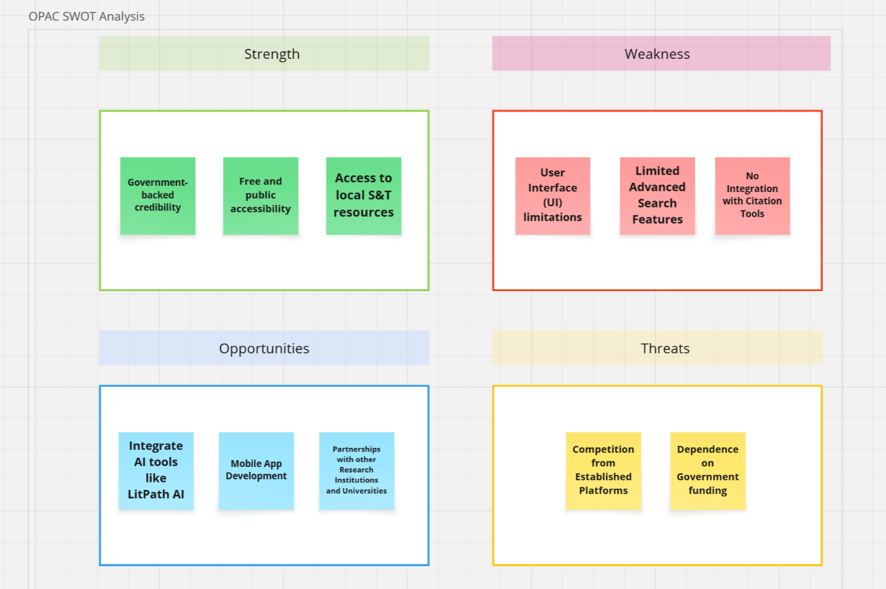

Figure 1. SWOT Analysis

This SWOT analysis identifies the strategic position of the current OPAC system by categorizing its internal attributes as strengths and weaknesses, and external factors as opportunities and threats.

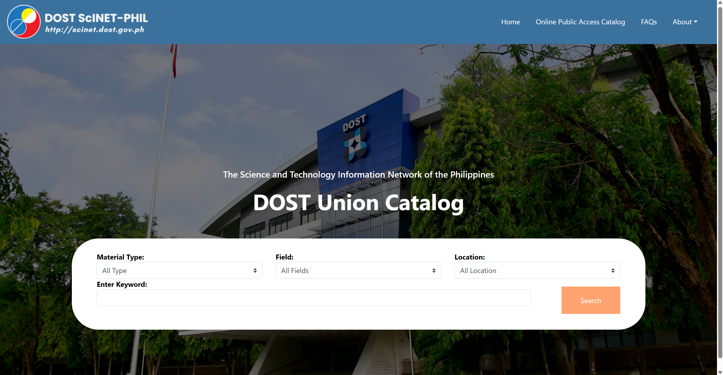

Figure 2. DOST OPAC current system

The current interface of the DOST Online Public Access Catalog (OPAC) system, displaying the search functionality with options for material type, field, and location.

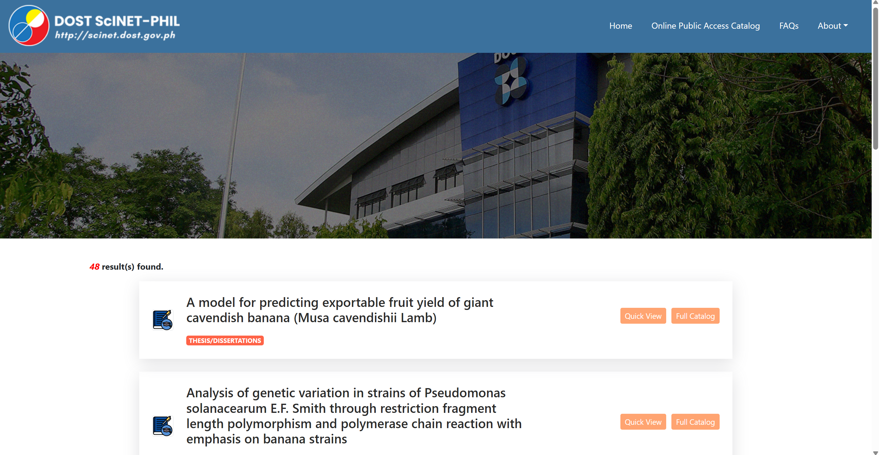

Figure 3. DOST OPAC current system search results

An example of search results displayed within the DOST OPAC current system, showing the retrieved records related to thee entered keyword.

# Proposed Solution

## Technical Background

A key opportunity in this project lies in the absence of a dedicated, modern search engine within the DOST-STII library's current web portal, which limits users' ability to efficiently access its most valuable resource: the collection of theses and dissertations. The proposed LitPath AI system is designed to address this gap by creating a specialized search interface that is tailored to the unique needs of this academic collection. This collection is a distinctive asset for DOST-STII, setting it apart from other libraries within the DOST network.

To capitalize on this opportunity, the LitPath AI system will be developed as a mobile-responsive web application, aimed at delivering a direct, and intuitive search experience. By securely interfacing with the existing OPAC database, LitPath AI will enhance search capabilities through advanced algorithms and AI-powered search results. Initially, the system will operate as a standalone tool, but it will be seamlessly integrated into the existing OPAC website from the outset, ensuring a smooth transition for users who will access these enhanced search features without navigating to a separate application. In the long term, the success of LitPath AI's advanced search features will serve as a foundation for its formal adoption within the main DOST OPAC system, ultimately improving the search engine's overall performance and user experience. Our team has already created detailed mockups in Figma to guide the development process.

**Hardware**

Our hardware strategy is designed to optimize performance for two key groups: the Development Team building the application and the End-Users who will access it.

* Development Team Specifications

To ensure a highly efficient and bottleneck-free development process, our team requires workstations that can handle the demands of modern web development, including simultaneous code compilation, local server management, and application testing.

* + Processor: Intel Core i5 or AMD Ryzen 3 (or better)
  + RAM: 8 GB (Minimum)
  + Storage: A minimum of 256 GB of storage space is required for a productive workflow. However, 512 GB or more is highly recommended to accommodate multiple project environments and larger developer tools.
* End-User Accessibility

LitPath AI is engineered for universal access, ensuring no user is left behind due to hardware limitations.

* + No Special Hardware Required: The system is a responsive web application accessible through a standard web browser.
  + Device Compatibility: It is fully functional on any modern desktop, laptop, tablet, or smartphone, regardless of the operating system.

**Software**

The project will be built using a powerful and proven technology stack. The backend will be developed with Laravel (PHP) to handle the system's core logic and to create the REST API needed for the user interface and future integrations. The frontend will be built with Vue.js for a dynamic and responsive user experience. All code will be version-controlled using GitHub.

The specific components of this technology stack are detailed in Table 3 below.

Table 3.

Proposed Software Stack & Platforms

|  |  |  |
| --- | --- | --- |
| **Component** | **Proposed Version/Technology** | **Justification** |
| Prototyping Tool | Figma | A standard tool for designing and testing the user interface before coding begins. |
| Version Control | GitHub | The industry-standard platform for storing code, tracking changes, and enabling team collaboration. |
| Web Server | Apache | A powerful, widely used, and reliable web server that works excellently with PHP and Laravel. |
| Backend Framework | Laravel | A strong PHP framework for building the project's main functions and its essential REST API, key for connecting to the frontend and for future integration. |
| Frontend Framework | Vue.js | A modern tool for building a fast and responsive user interface that connects to the Laravel backend. |
| Database | MySQL | A popular and reliable open-source database that works very well with Laravel. |

Data Integration and Management

Our approach to data integration is designed to maintain both the integrity and speed of the system while protecting the client's existing data.

1. Dedicated LitPath AI Database: The LitPath AI system will utilize its own dedicated MySQL database to store system-specific data, such as search analytics and cached information, which are essential for delivering fast search results.
2. Synchronization with the Source of Truth: The DOST-STII OPAC database remains the authoritative source for all theses and dissertations. LitPath AI will not modify the OPAC database but will periodically synchronize data from it using a secure, read-only process.
3. Content Management: The DOST-STII team will continue to manage and add scholarly materials via their existing OPAC system. LitPath AI will automatically detect and import new entries during synchronization, ensuring the system’s search index is always up to date.
4. Future-Ready API: While the REST API will primarily facilitate communication between the Vue.js frontend and the Laravel backend, it is also designed for future integration. This enables the main OPAC system to call LitPath AI’s advanced search functionality if needed.

**Peopleware**

The peopleware for this project consists of the Development Team and the system's End-Users. The Development Team is composed of project members fulfilling the roles of backend/frontend developers, UI/UX designers, and QA testers. The End-Users are divided into Primary Users (students, researchers) and Administrative Users (DOST-STII librarians).

**Network**

The system requires a stable internet connection for all users to access the deployed application.

* Development Phase: During development and testing, the application will be hosted on the team's local computers.
* Production Deployment: For the final launch, the system will be hosted on the client's physical server. This on-premises deployment eliminates external hosting fees. All connections will be secured via HTTPS/SSL, and we will work with your IT staff to establish a reliable backup and recovery plan for the application and its data.

## Feasibility

### **Operational Feasibility**

The proposed LitPath AI system is considered highly feasible from an operational standpoint, based on strong institutional support, clear user need, and a well-defined implementation plan.

The project has received strong support from both DOST-STII management and its target users (researchers, students, and staff). There is a clearly identified operational need, as the current OPAC's limitations in search and discovery create significant inefficiencies. This widespread support ensures that the project is aligned with organizational goals and user demands.

LitPath AI is designed to improve, not replace, existing staff. By automating resource discovery and citation, the system will enhance staff productivity and improve user satisfaction. It will integrate with the existing OPAC, providing a centralized and significantly more powerful tool for research. This streamlined workflow is expected to be adopted smoothly after a brief adjustment period.

A smooth transition for all users will be facilitated through clear documentation, hands-on training, and dedicated support. We will also coordinate directly with the DOST-STII technical team to ensure a seamless on-premises deployment and integration. The active involvement of end-users throughout the planning and development phases ensures the final product is intuitive and built to meet their actual needs, which greatly increases the likelihood of successful and rapid adoption.

The project aligns perfectly with DOST-STII’s mission to provide better access to science and technology resources. From a legal and ethical standpoint, no conflicts have been identified, as the system is designed to comply fully with Anti-Red Tape Authority (ARTA) guidelines. User privacy is a top priority and will be managed with a clear distinction between user types. For the public, the search function will be fully anonymous, requiring no registration or collection of personal data. For administrative users, such as librarians needing to view analytics, access will be secured through a login using an email and password. All administrative account data will be handled in strict compliance with Republic Act No. 10173, the Data Privacy Act of 2012. Ultimately, by providing a modern and effective tool, the project is expected to positively enhance the image and utility of the DOST-STII Library.

### **Economic Feasibility**

COST ANALYSIS

While a detailed budget has not been established at this preliminary stage, the project's main costs have been identified. The primary investment is the significant time and effort allocated by the development team to design, build, and test the system. In terms of operational impact, a brief adjustment period for library staff and users is anticipated as they become familiar with the new interface and features. Looking ahead, the project has been designed for minimal to zero recurring operational expenses. By leveraging DOST-STII's existing on-premise server for hosting and utilizing a technology stack built on powerful, open-source software (Laravel, Vue.js, MySQL), the project avoids the significant, ongoing costs typically associated with cloud hosting subscriptions and software licensing fees. The primary investment remains the one-time allocation of the development team's time and effort. It is also crucial to consider the opportunity cost of not pursuing this project, which includes continued research inefficiencies and the persistent underutilization of the library's valuable academic collection.

BENEFIT ANALYSIS

Even without concrete cost figures, the *LitPath AI* system is expected to deliver significant tangible and intangible benefits:

* Improved Efficiency: By reducing the time and effort users spend searching for theses and dissertations, the system will increase overall productivity for students, researchers, and library staff.
* Enhanced User Satisfaction: The user-friendly interface and AI-powered search engine will improve the research experience, leading to higher satisfaction and better academic outcomes.
* Better Resource Utilization: The system's analytics features can provide better data on search trends and popular research topics, enabling library management to make more informed decisions about collection development and resource allocation.
* Support for Academic Integrity: Automated citation features will promote proper referencing, benefiting the broader academic community.
* Alignment with Organizational Goals: The project supports DOST-STII’s mission to improve access to information and contributes to sustainable education initiatives.

Beyond measurable gains, the system is expected to improve employee morale by reducing frustration with the current search process and empowering users with better tools. This can lead to improved motivation and engagement among both library staff and patrons.

VALUE PROPOSITION & RETURN ON INVESTMENT (ROI)

The value of the LitPath AI project is measured not by revenue, but by the substantial return on investment it delivers to the DOST-STII library and its users. The primary return is the dramatic improvement in research efficiency, saving invaluable time for students, researchers, and staff.

This return is amplified by the project's highly cost-effective design. By leveraging the institution's existing server infrastructure and open-source technologies, the system is engineered for long-term sustainability with virtually no recurring operational costs. This ensures that the initial investment in development continues to deliver value for years to come, maximizing the impact on the institution's reputation and its ability to attract future partnerships and funding.

### **Technical Feasibility**

The LitPath AI project is technically possible for our team to build using today's tools. Our plan for handling the library's data is both safe and simple. We will connect to the existing DOST-STII database to regularly get its information, which means we do not have to perform a difficult and risky transfer of all the data at once.

We will build the system using well-known and free software like Laravel, Vue.js, and MySQL. Because we are using these free tools and will host the system on the library’s own server, there will be no monthly or yearly fees for software or hosting. This makes the project very affordable to run long-term.

To reduce the risk of problems, we have already created a detailed design model that gives us a clear plan for development. Finally, the modern way we are building the system ensures it will be reliable, can easily grow to support more users in the future, and will be simple to connect with the main DOST OPAC system when needed.

## Requirements Analysis

### **Project Vision**

For library users who need to find related theses and dissertations within the DOST-STII Library, LitPath AI is an AI-powered search engine system that quickly suggests related research based on the user’s interest. Unlike other academic search engines, it provides semantically relevant search results and offers features like citation generation and filtering designed to the library's needs.

### **Prototype** (Mock Flow / Wireframe)

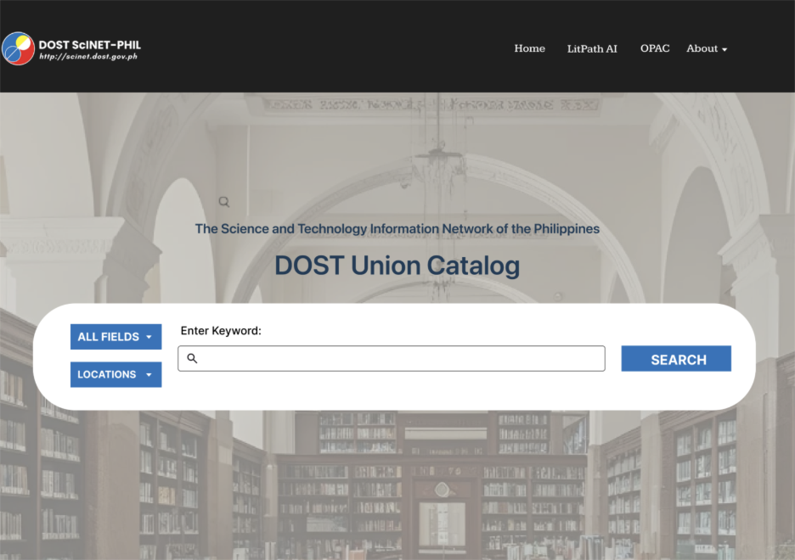

Figure 4. DOST Scholar’s Theses and Dissertation Home page

This figure displays the homepage, featuring a navigation bar (Home, OPAC, and About), a search bar with search filter options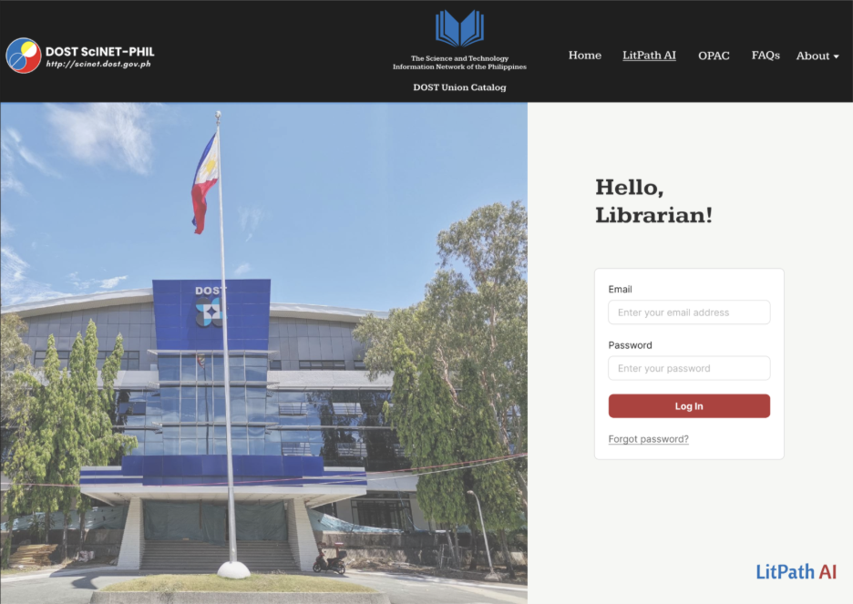

Figure 4. Admin Login page

This figure shows the login page for DOST Librarians to access the administrative dashboard.

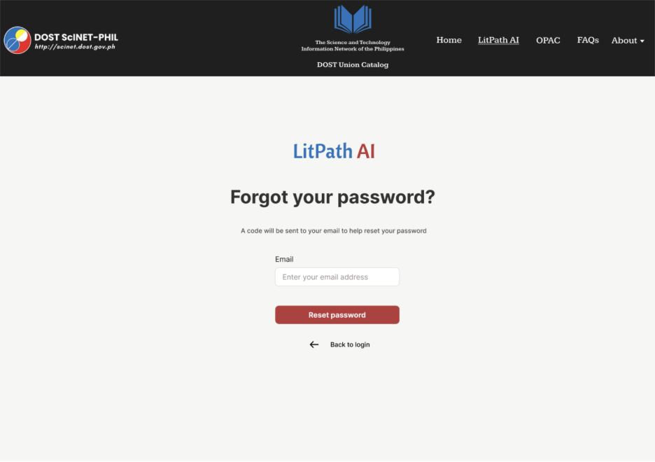

Figure 5. Forgot your password page

This figure shows the page where DOST Librarians can enter their email address to receive a verification code for password reset.

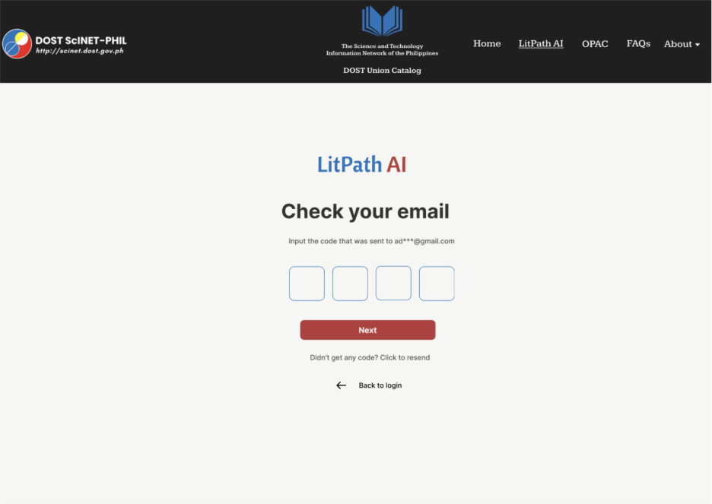

Figure 6. Code verification for forgotten password page

This figure displays the page where a librarian enters the verification code sent to their email.

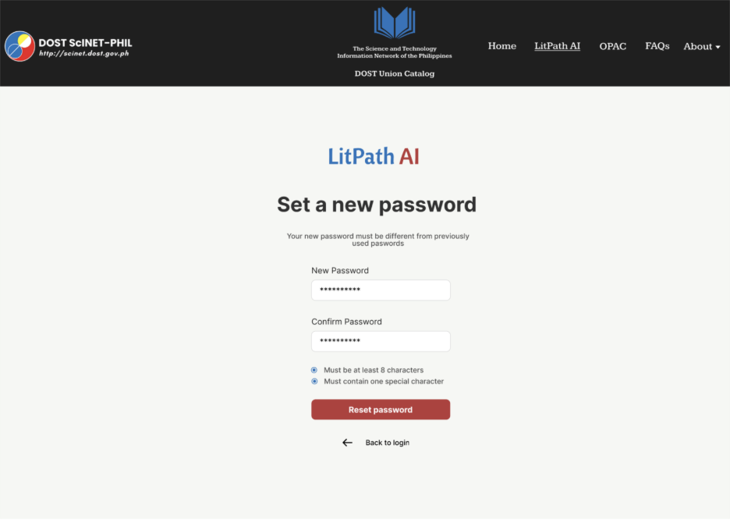

Figure 7. Setting New password page

This figure shows the page where a librarian can set up a new password after successful code verification.

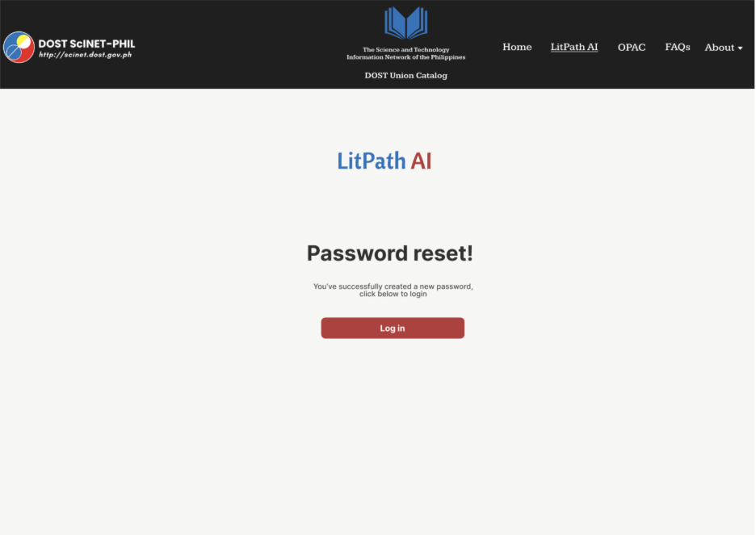

Figure 8. Confirmation of password reset page

This figure confirms that the librarian's password has been successfully reset to the new password.

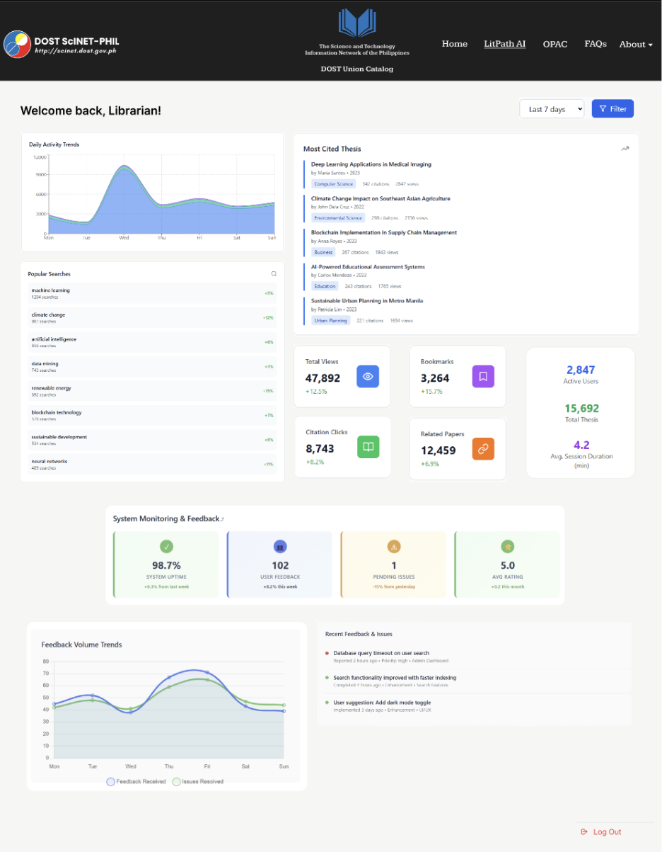

Figure 9. Admin Dashboard

This figure shows the administrative dashboard accessible to librarians after logging in, displaying analytics.

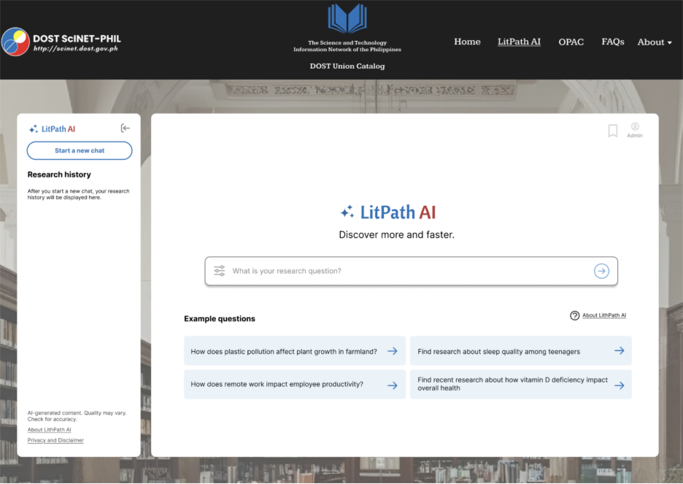

Figure 10. LitPath AI Homepage

This figure presents the homepage of LitPath AI.

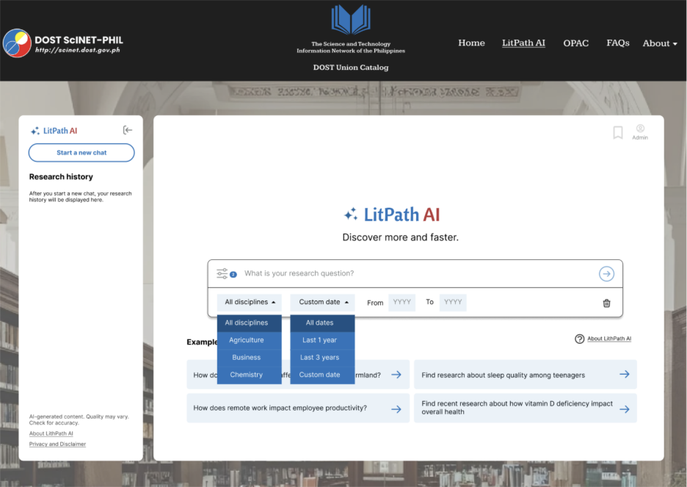

Figure 11. LitPath AI: Filters

This figure shows the search filters provided by LitPath AI.

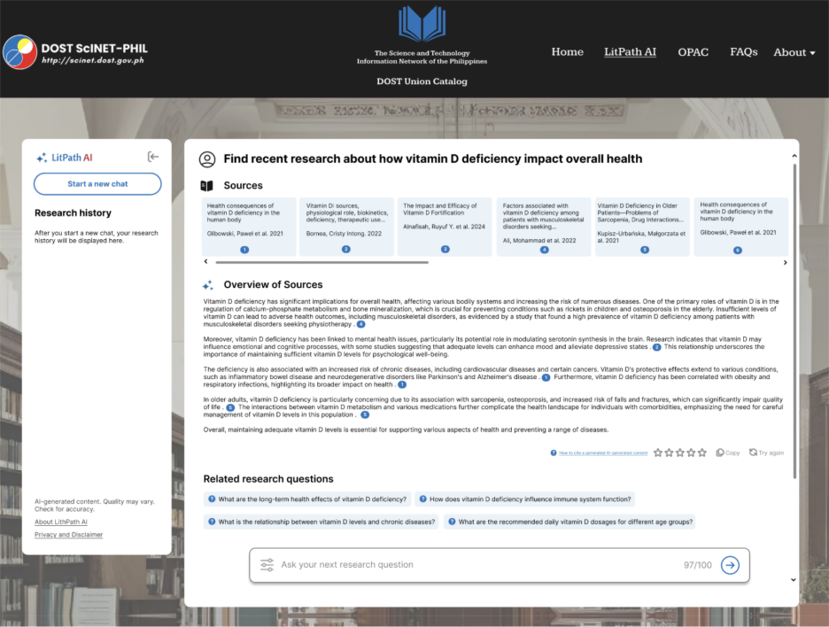

Figure 12. LitPath AI: Respons

This figure shows an example of the search results you will be provided with when you ask a research question.

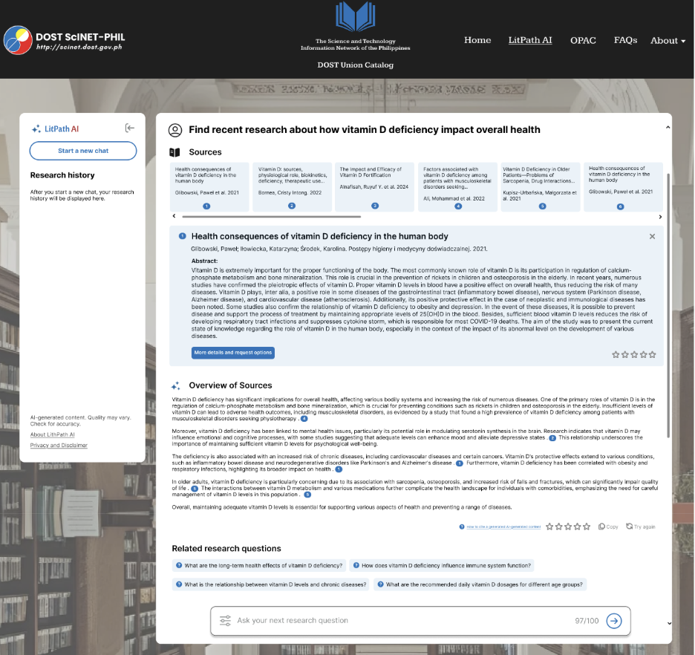

Figure 13. LitPath AI: Quick view of sources

This figure displays how when you click one of the sources provided it will show you a quick view where it shows the authors, publication year and abstract.

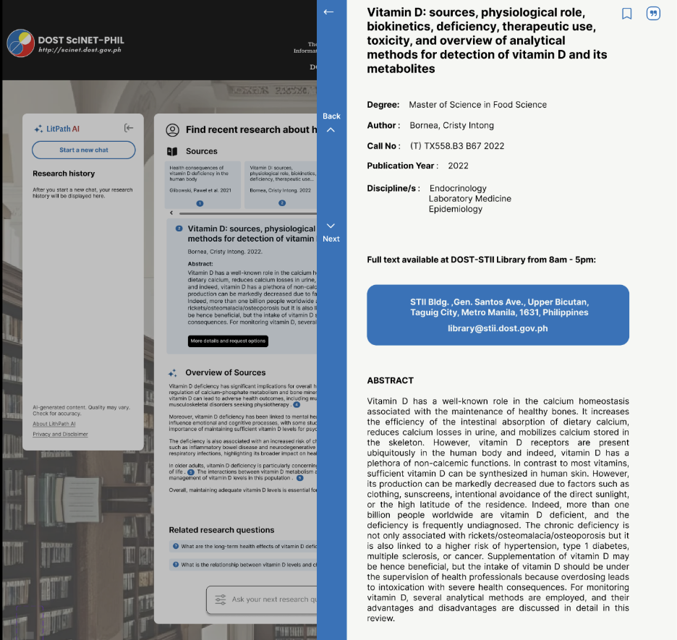

Figure 14. Source details overlay

This figure shows the more detailed information of the sources provided with your search results. This includes, the degree, author/s, call number, publication year, disciplines and abstract.

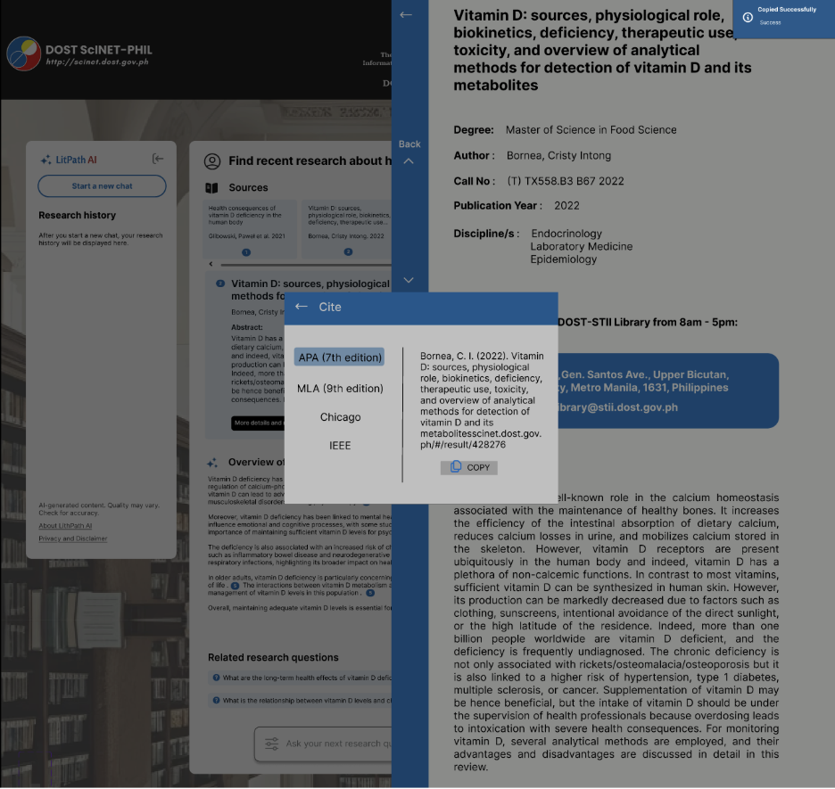

Figure 15. Citation cpop-up

This figure shows a citation pop-up that allows users to choose a citation format and they can then copy it.

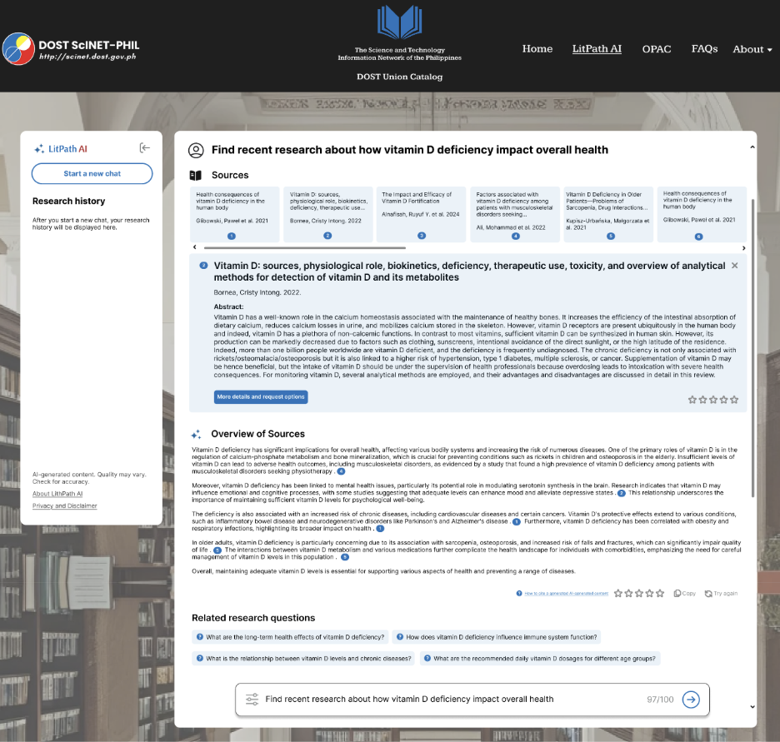

Figure 16. LitPath AI: Try again

This figure shows that if you click on the “try again”, it will put your research question in the search bar again so you can be shown a different answer.

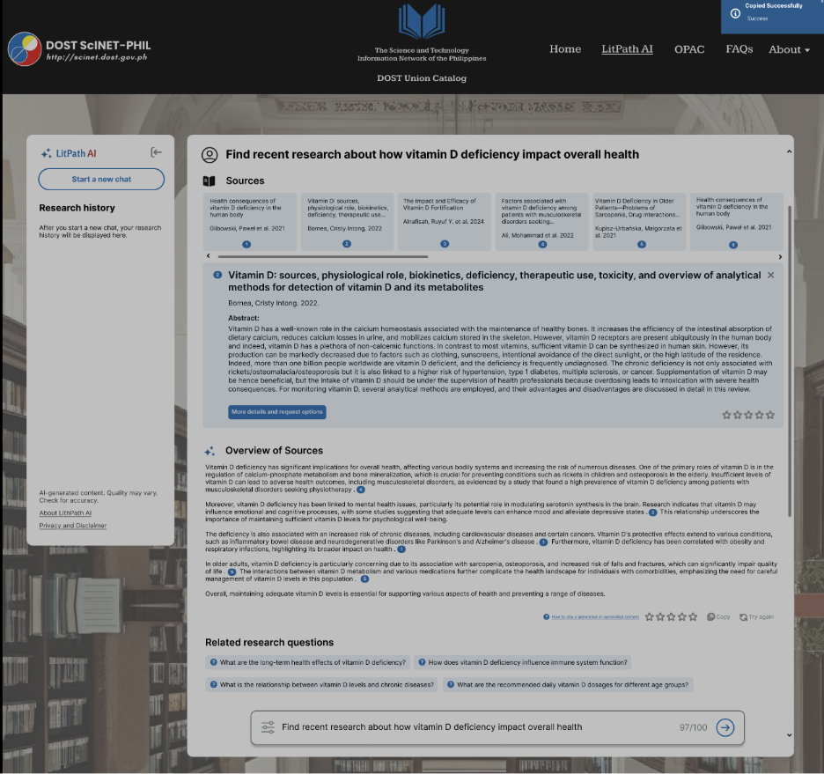

Figure 17. LitPath AI: Successfully copied AI response

This figure shows a success pop-up when you copy the AI response provided.

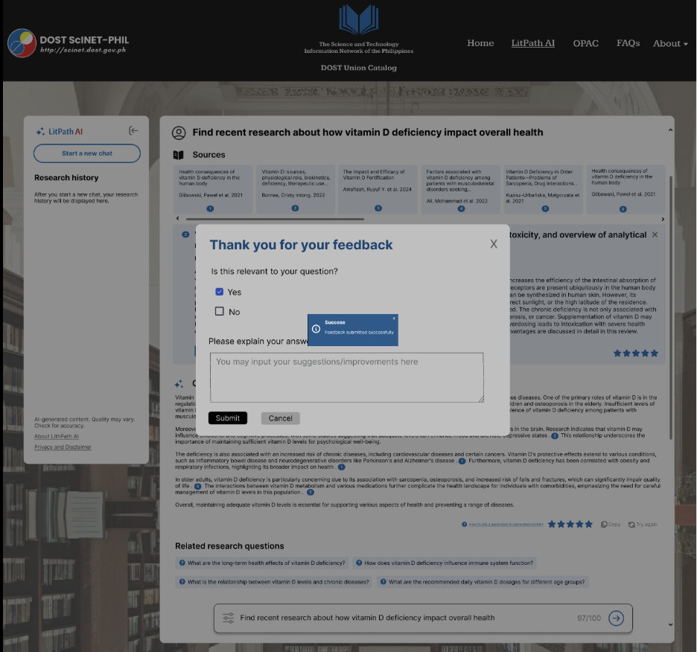

Figure 18. LitPath AI: LitPath AI: User Feedback

This figure shows the feedback pop-up where users can rate it 1-5 stars then provide an answer to the relevance question and optionally can provide an explanation.

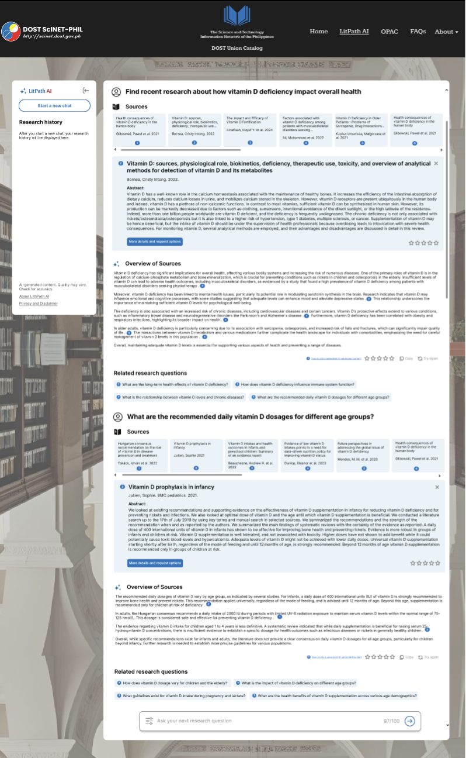

Figure 19. LitPath AI: Follow-up Question

This figure shows the output if you ask a follow-up question.

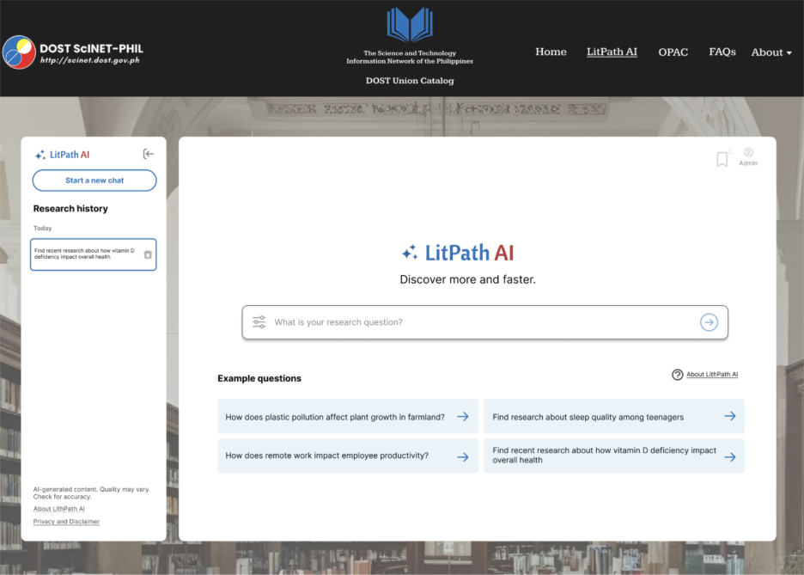

Figure 20. LitPath AI: Search History

This figure shows the search history panel on the left side.

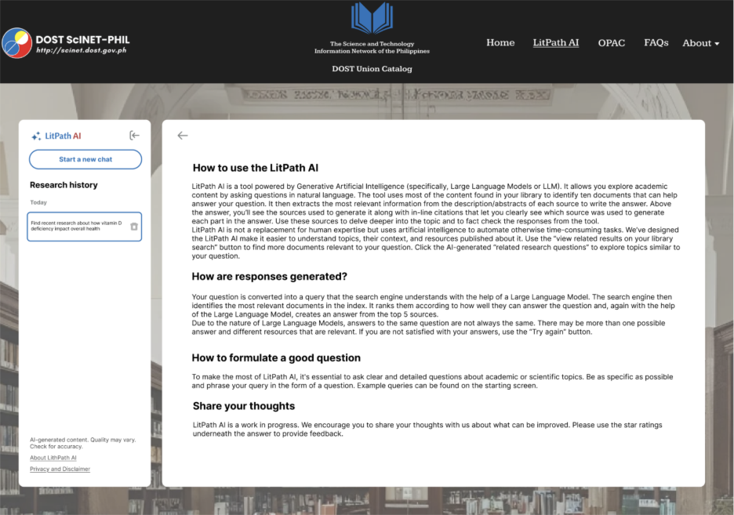

Figure 21. LitPath AI: About LitPath AI

This figure shows the About LitPath AI where it shows what it is, how the responses are generated, how to formulate a good question, and encouragement to give feedback.

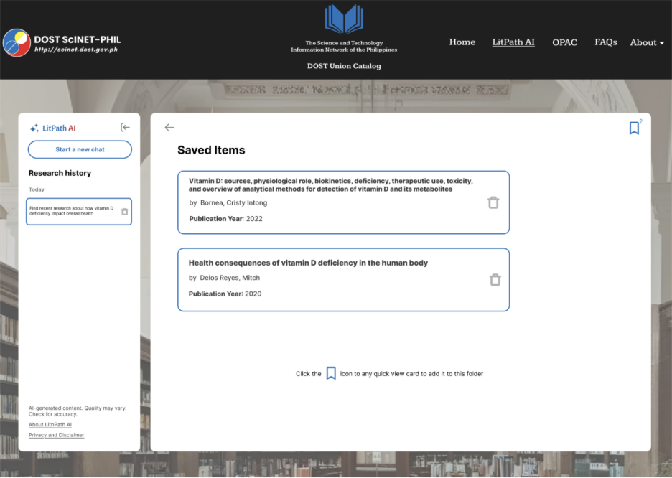

Figure 22. LitPath AI: Saved Items

This figure shows the Saved Items section where you can find all your bookmarked research papers in one place.

### **Project Lean Canvas**

Table 4. Project Lean Canvas

|  |  |  |  |  |  |
| --- | --- | --- | --- | --- | --- |
| PROBLEM | SOLUTION | UNIQUE VALUE PROPOSITION | | UNFAIR ADVANTAGE | CUSTOMER SEGMENTS |
| * Limited Search Mechanism * Poor Relevance and Efficiency * Lengthy Searching Performance * Lack of Essential Research Support Features | * Provide advanced filters by titles, authors, abstracts, descriptions, recency, and dates * Provide AI-powered search suggestions based on subject relevance * Redesign interface to be user-friendly * Make a built-in automated citation generator | * Enhances research efficiency by providing subject-aligned search results for theses and dissertations from the DOST-STII collection, enabling easy access to valuable academic resources. * Provide a user-friendly and enhanced interface for navigation in the simplest manner | | * Citation and filtering features * AI-powered, relevance-based search capabilities | * Students and academic researchers * Educators and librarians * DOST researchers and employees * Other professionals and academe |
| KEY METRICS | CHANNELS |
| * Accuracy of relevant search results * Reduction in search time. * User satisfaction on research efficiency. | * Embedded into the current website * Librarian reference services * DOST emails, webinars, orientations, etc. |
| COST STRUCTURE | | | REVENUE STREAM | | |
| * Development costs * Integration with OPAC * User testing and feedback collection * Maintenance and updates | | | * Value through public service and institutional improvement * Increased library usage and improved research outcomes * No revenue, however, necessary government funds will be provided for the maintenance of the project | | |

### **User Classes and Characteristics**

Table 5. List of Roles and Descriptions

|  |  |
| --- | --- |
| **Roles** | **Description** |
| **Students/Researcher** | Conducting research for academic papers or projects. Their primary need is to find thesis and dissertation related to their works by searching with keywords like title, author, abstract, description, recency, and dates to find |
| **Library Staff** | The acting facilitators and administrators who have used the system to assist library users during reference interviews and understand usage analytics can provide feedback for the system's improvement. They need reliable tools to offer better service delivery and to maintain/organize the library catalog. |

### **Product Backlog**

Table 6. Updated Product Backlog

|  |  |  |  |  |
| --- | --- | --- | --- | --- |
| PRODUCT BACKLOG | | | | |
| ID | **As a…** | **I want to be able to…** | **So that…** | **Priority** |
| 1 | Student/Researcher | prompt research questions and receive AI-powered ranked results | I can easily find appropriate research | Must |
| 2 | Student/Researcher | view comprehensive details of selected thesis/dissertation including abstract, call number, and library location | I can narrow down the content that fits my academic needs | Must |
| 3 | Student/Researcher | bookmark theses/dissertations for future reference | I can save important research materials and access them later | Must |
| 4 | Student/Researcher | generate and copy citations in various formats (APA, MLA, IEEE) with one click | I can properly cite academic works with ease and accuracy | Must |
| 5 | Student/Researcher | provide feedback by rating AI responses (1-5 stars) and submit comments | I can help improve the service quality and share my experience | Should |
| 6 | Student/Researcher | ask follow-up questions based on AI's initial response | I can continue my research session with maintained context and get deeper insights | Must |
| 7 | Student/Researcher | view my research history and resume previous sessions | I can track my research progress and continue from where I left off | Should |
| 8 | Student/Researcher | filter search results by discipline and publication date | I can narrow down content that fits my specific academic needs | Must |
| 9 | Student/Researcher | use a user-friendly interface | I can explore new research directions and discover relevant topics | Should |
| 10 | Student/Researcher | receive AI-generated related research questions | I can quickly understand key themes and trends in my research area | Should |
| 11 | Student/Researcher | experience fast loading of search results | I can browse efficiently without delays | Must |
| 12 | Student/Researcher | use a user-friendly interface | I can access materials without needing a tutorial | Must |
| 13 | Student/Researcher | receive clarifying suggestions when my query is vague | I can refine my search and get better results | Should |
| 14 | Library Staff | securely manage my admin account with login and password recovery | I can safely access administrative functions | Must |
| 15 | Library Staff | view comprehensive usage analytics including most searched topics, user activity trends, and system performance | I can gain insights to support platform improvements and decision-making | Should |
| 16 | Library Staff | view and analyze user feedback and ratings | I can identify areas for improvement and track user satisfaction | Should |
| 17 | System | securely access OPAC database with read-only permissions | users can get up-to-date thesis/dissertation information | Must |
| 18 | AI System | analyze user queries for intent and context using natural language processing | I can understand research needs and provide relevant results | Must |
| 19 | AI System | rank theses/dissertations by relevance using advanced algorithms | users receive the most pertinent research materials first | Must |

### **Product Roadmap**

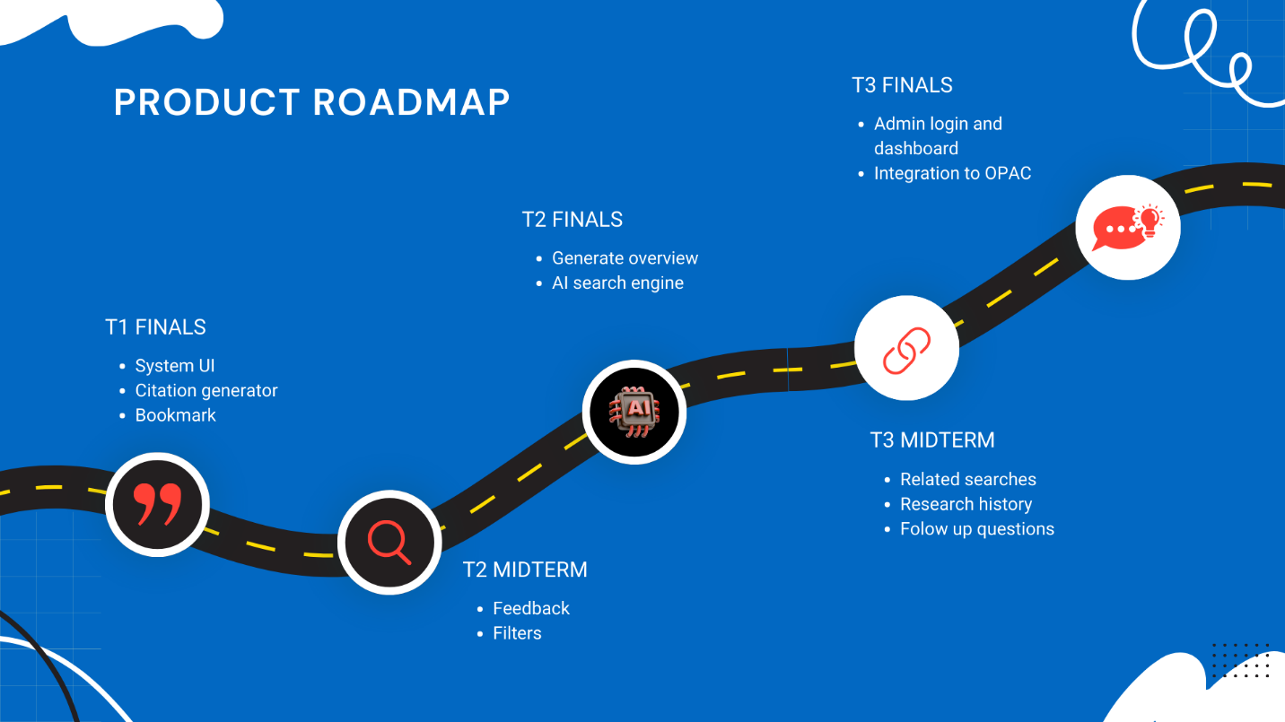

Figure 23. Product Roadmap

The product roadmap outlining key features and functionalities to be implemented across different development phases, from T1 Finals to T3 Finals, including integration with OPAC and AI-powered enhancements.

### **Release Plan**

[HecTech - LitPath AI Release Plan ver.2.0.docx](https://asiapacificcollege.sharepoint.com/:w:/r/sites/HecTech2/Shared%20Documents/MNTSDEV%20Final%20Requirements/HecTech%20-%20LitPath%20AI%20Release%20Plan%20ver.2.0.docx?d=w530068ba125946769726e11520ad086d&csf=1&web=1&e=1tER2s)

### **Use Case Diagram**

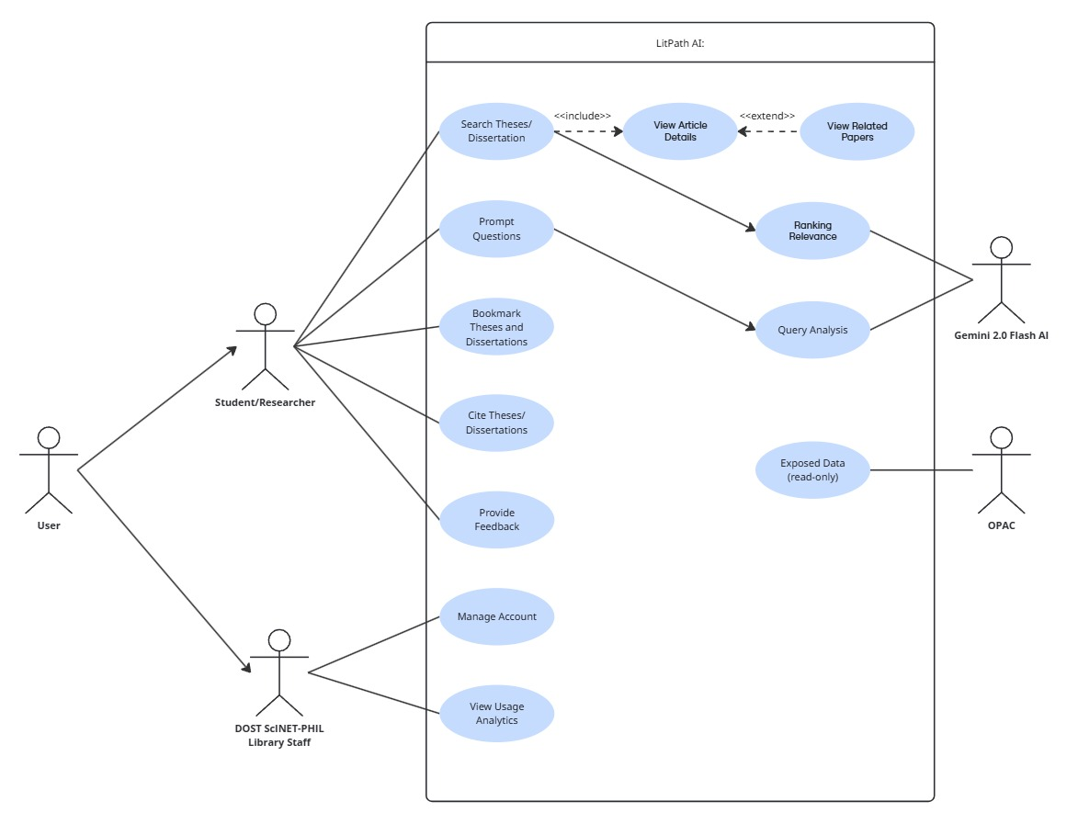

Figure 24. Use Case Diagram

 A use case diagram showing the interactions between different actors (Student/Researcher and DOST ScINET-PHIL Library Staff) and the OPAC system, specifically highlighting functionalities within the LitPath AI module such as searching, viewing details, and AI-driven interactions, alongside administrative functions.

**Business Requirements (BR) OR Product Requirements (PR)**

Table 5. List of Requirements

|  |  |  |
| --- | --- | --- |
| **ID** | **Requirement** |  |
| BR-01 | User should be able to prompt research questions |  |
| BR-02 | User should be able to view more details of thesis/dissertation |  |
| BR-03 | User should be able to bookmark thesis/dissertations |  |
| BR-04 | User should be able to cite thesis/dissertation |  |
| BR-05 | User should be able to provide feedback |  |
| BR-06 | User should be able to prompt follow-up questions |  |
| BR-07 | User should be able to view their research history |  |
| BR-08 | User should be able to filter by discipline and date |  |
| BR-09 | Library staff can manage account |  |
| BR-10 | Library staff can view usage analytics |  |
| BR-11 | Library staff can view feedback |  |
| BR-12 | System can provide related research questions |  |
| BR-13 | System can generate overview of research topics |  |
| BR-14 | System can read OPAC database |  |
| BR-15 | AI can analyze user queries |  |
| BR-16 | AI can rank theses/dissertations by relevance |  |

### **Use Case Full Description**

*Table 2. Use Case Name: Prompt research questions*

|  |  |
| --- | --- |
| Use Case ID: | *UC-01* |
| Author | *Jenine Elaine Dulay* |
| Purpose | *Allow users to ask research questions and receive AI-powered results* |
| Requirement Traceability | *BR-01* |
| Priority | *High* |
| Preconditions | * *System is online* * *User can access LitPath AI platform* |
| Postconditions | * System returns relevant theses/dissertations based on AI analysis |
| Actors | *Student/Researcher* |
| Flow of Actions | ***Basic Flow***   1. *Open “LitPath AI”* 2. Click search bar or "Start a new chat" 3. User enters research question 4. *Click search button* 5. System processes query through AI analysis 6. System ranks relevant results 7. Display ranked sources and search results to user     ***Alternative Flow***  *Vague/Incorrect keywords*   1. *Open “LitPath AI”* 2. Click search bar or "Start a new chat" 3. User enters vague research question 4. *Input vague or incorrect keywords and/or add relevant filters* 5. System detects vague query 6. AI provides clarifying suggestions and related research questions 7. User can select from suggestions or refine their question |

*Table 3. Use Case Name: View more details*

|  |  |
| --- | --- |
| Use Case ID: | *UC-02* |
| Author | *Jenine Elaine Dulay* |
| Purpose | *Allow users to view comprehensive details of selected thesis/dissertation* |
| Requirement Traceability | *BR-02* |
| Priority | *High* |
| Preconditions | * *User must be on search results page* * *System is online* |
| Postconditions | * User can see complete catalog information and abstract of theses or dissertations |
| Actors | *Student/Researcher* |
| Flow of Actions | ***Basic Flow***   1. *User selects thesis/dissertation from search results* 2. *Click "More details and request options"* 3. *Display thesis details including title, author, call number, publication year, abstract, disciplines, and library location* 4. *System records view for analytics* 5. *User reads detailed information* |

*Table 4. Use Case Name: Bookmark Theses and Dissertations*

|  |  |
| --- | --- |
| Use Case ID: | *UC-03* |
| Author | *Jenine Elaine Dulay* |
| Purpose | *Allow users to save theses/dissertations for future reference* |
| Requirement Traceability | *BR-03* |
| Priority | *High* |
| Preconditions | * User must be on "view more details" overlay * *System is online* |
| Postconditions | * Selected thesis/dissertation is saved to user's bookmarks |
| Actors | *Student/Researcher* |
| Flow of Actions | ***Basic Flow***   1. *User views "view more details” overlay* 2. *Click bookmark/ribbon icon* 3. *System saves item to bookmarks* 4. *Item appears in "Saved Items" section* 5. *System records bookmark action for analytics* |

*Table 5. Use Case Name: Cite Theses/Dissertations*

|  |  |
| --- | --- |
| Use Case ID: | *UC-04* |
| Author | *Jenine Elaine Dulay* |
| Purpose | *Allow users to generate citations in various academic formats* |
| Requirement Traceability | *BR-04* |
| Priority | *High* |
| Preconditions | * User must be on "viewing more details" overlay * *System is online* |
| Postconditions | * Citation is generated in selected format and ready for copying |
| Actors | *Student/Researcher* |
| Flow of Actions | ***Basic Flow***   1. *User views "view more details” overlay* 2. *Click on cite icon* 3. *Choose citation format (APA, MLA, Chicago, IEEE)* 4. *System generates formatted citation* 5. *User copies citation to clipboard* 6. *System records citation generation for analytics* |

*Table 6. Use Case Name: Provide Feedback*

|  |  |
| --- | --- |
| Use Case ID: | *UC-05* |
| Author | *Jenine Elaine Dulay* |
| Purpose | *Allow users to rate and provide feedback on AI responses* |
| Requirement Traceability | *BR-05* |
| Priority | *High* |
| Preconditions | * User must have received AI response * *System is online* |
| Postconditions | * Feedback is saved in system database for review |
| Actors | *Student/Researcher* |
| Flow of Actions | ***Basic Flow***   1. *User receives AI response* 2. *Rating interface appears* 3. *User selects star rating (1-5)* 4. *Optional: User enters text feedback* 5. *Click "Submit"* 6. *System confirms feedback received* 7. *Feedback stored for admin review* |

*Table . Use Case Name: Prompt follow-up questions*

|  |  |
| --- | --- |
| Use Case ID: | *UC-06* |
| Author | *Jenine Elaine Dulay* |
| Purpose | *Allow users to ask follow-up questions based on AI’s initial response, continuing the research session with context.* |
| Requirement Traceability | *BR-06* |
| Priority | *High* |
| Preconditions | * *User* must have received AI response * *System is online* |
| Postconditions | * System processes follow-up questions with context from previous queries |
| Actors | *Student/Researcher* |
| Flow of Actions | ***Basic Flow***   1. *User receives AI response* 2. *User types a follow-up question in the input box* 3. *Press Enter or Click on “enter” button on search bar* 4. *System analyzes follow-up question in context of previous conversation* 5. *System retrieves and ranks new results relevant to refined query* 6. *Updated results displayed alongside prior conversation history*     ***Alternative Flow: Unclear Follow-up***   1. *User asks vague follow-up question* 2. *System detects ambiguity* 3. *AI provides clarifying suggestions or related options* 4. *User selects/refines their follow-up question* 5. *System processes refined query and updates results* |

*Table 8. Use Case Name: View Research History*

|  |  |
| --- | --- |
| Use Case ID: | *UC-07* |
| Author | *Jenine Elaine Dulay* |
| Purpose | *Allow users to access their previous search sessions* |
| Requirement Traceability | *BR-07* |
| Priority | *High* |
| Preconditions | * *User has conducted previous searches* * *System is online* |
| Postconditions | * User can view and resume previous research sessions |
| Actors | *Student/Researcher* |
| Flow of Actions | ***Basic Flow***   1. *User clicks "Research History" in sidebar* 2. *System displays list of previous sessions* 3. *User clicks on desired session* 4. *System loads previous conversation with full context* 5. *User can view and continue from where they left off* |

*Table . Use Case Name: Filter Discipline/Date*

|  |  |
| --- | --- |
| Use Case ID: | *UC-08* |
| Author | *Jenine Elaine Dulay* |
| Purpose | *Allow users to narrow search results by discipline and publication date* |
| Requirement Traceability | *BR-08* |
| Priority | *High* |
| Preconditions | * *User must be on search bar* * *System is online* |
| Postconditions | * Results are filtered according to selected criteria |
| Actors | *Student/Researcher* |
| Flow of Actions | ***Basic Flow***   1. *User is on search bar* 2. *Click "Filters" option* 3. *Select discipline categories (Agriculture, Business, Chemistry, etc.)* 4. *Select date range (Last 1 Year, Last 3 Years, Custom Date)* 5. *System updates results based on filter criteria* |

*Table . Use Case Name: Manage Account*

|  |  |
| --- | --- |
| Use Case ID: | *UC-09* |
| Author | *Jenine Elaine Dulay* |
| Purpose | *Allow library staff to securely access admin functions* |
| Requirement Traceability | *BR-09* |
| Priority | *High* |
| Preconditions | * *Staff must have valid credentials in database* * *System is online* |
| Postconditions | * *Library staff can access admin dashboard* |
| Actors | *DOST SciNET-PHIL Library Staff* |
| Flow of Actions | ***Basic Flow***   1. *User clicks on Admin icon* 2. *Enter username and password* 3. *Click "Log In"* 4. *System validates credentials* 5. *Redirect to admin dashboard*     ***Alternative Flow: Forgot Password***   1. *Click "Forgot Password" link* 2. *Enter email address* 3. *Receive verification code via email* 4. *Enter verification code* 5. *Set new password* 6. *Receive confirmation and return to login* |

*Table . Use Case Name: View Usage Analytics*

|  |  |
| --- | --- |
| Use Case ID: | *UC-10* |
| Author | *Jenine Elaine Dulay* |
| Purpose | *Allow library staff to monitor platform performance and user activity* |
| Requirement Traceability | *BR-10* |
| Priority | *High* |
| Preconditions | * *Staff must be logged in as admin* * *System is online* |
| Postconditions | * *Staff can view usage statistics* |
| Actors | *DOST SciNET-PHIL Library Staff* |
| Flow of Actions | ***Basic Flow***   1. *Library staff logs into admin dashboard* 2. *View charts showing most searched topics, user activity trends, popular theses, and system performance metrics* 3. *Library staff can log out of the admin dashboard* |

*Table . Use Case Name: View Feedback*

|  |  |
| --- | --- |
| Use Case ID: | *UC-11* |
| Author | *Jenine Elaine Dulay* |
| Purpose | *Allow library staff to review user feedback and ratings* |
| Requirement Traceability | *BR-11* |
| Priority | *High* |
| Preconditions | * *Staff must be logged in as admin* * *System is online* |
| Postconditions | * *Staff can analyze user feedback for system improvements* |
| Actors | *DOST SciNET-PHIL Library Staff* |
| Flow of Actions | ***Basic Flow***   1. *Library staff accesses admin dashboard* 2. *Navigate to "Feedback" section* 3. *View user ratings, comments, and suggestions* 4. *Analyze trends and identify improvement areas* |

*Table . Use Case Name: Provide Related Research Questions*

|  |  |
| --- | --- |
| Use Case ID: | *UC-12* |
| Author | *Jenine Elaine Dulay* |
| Purpose | *Generate contextually relevant research questions to guide user research* |
| Requirement Traceability | *BR-12* |
| Priority | *High* |
| Preconditions | * *User has submitted initial query* * *AI has processed the query* |
| Postconditions | * *Staff can analyze user feedback for system improvements* |
| Actors | *LitPath AI System* |
| Flow of Actions | ***Basic Flow***   1. *User submits research query* 2. *AI analyzes query context and results* 3. *System generates 4 related research questions* 4. *Display suggested questions below main results* 5. *User can click on suggestions to initiate new searches* 6. *Context from previous search is maintained* |

*Table . Use Case Name: Generate Overview*

|  |  |
| --- | --- |
| Use Case ID: | *UC-13* |
| Author | *Jenine Elaine Dulay* |
| Purpose | *Provide answer overview of research topics/questions* |
| Requirement Traceability | *BR-13* |
| Priority | *High* |
| Preconditions | * *User query has been processed* * *Relevant results exist* |
| Postconditions | * *User receives summarized overview of the answer to their questions* |
| Actors | *LitPath AI System* |
| Flow of Actions | ***Basic Flow***   1. *AI processes user query and retrieved results* 2. *System analyzes common themes and trends* 3. *Generate overview of the answer to the user's research question* 4. *Present answer overview alongside sources* |

*Table . Use Case Name: Exposed Data (Read-only)*

|  |  |
| --- | --- |
| Use Case ID: | *UC-14* |
| Author | *Jenine Elaine Dulay* |
| Purpose | *Enable LitPath AI to securely access OPAC database for thesis/dissertation data* |
| Requirement Traceability | *BR-14* |
| Priority | *High* |
| Preconditions | * *LitPath AI system is online* * *OPAC database is accessible* * *Read-only credentials configured* |
| Postconditions | * *System successfully retrieves data for processing* |
| Actors | *LitPath AI System, DOST-STII OPAC Database* |
| Flow of Actions | ***Basic Flow***   1. *User submits query (trigger)* 2. *LitPath AI backend receives request* 3. *System establishes secure connection to OPAC database* 4. *Execute SQL query for relevant data* 5. *OPAC returns requested thesis/dissertation records* 6. *System processes data through AI analysis and ranking* 7. *Present results to user*     ***Alternative Flow: Connection Failure***   1. *User submits query (trigger)* 2. *LitPath AI backend receives request* 3. *Database connection fails* 4. *Log error and notify user of temporary unavailability* |

*Table . Use Case Name: Query Analysis*

|  |  |
| --- | --- |
| Use Case ID: | *UC-15* |
| Author | *Jenine Elaine Dulay* |
| Purpose | *Analyze user intent and context from research queries* |
| Requirement Traceability | *BR-15* |
| Priority | *High* |
| Preconditions | * *User has submitted query* * *AI system is operational* |
| Postconditions | * *Query intent is understood and ready for ranking process* |
| Actors | *Gemini AI 2.0 Flash, LitPath AI System* |
| Flow of Actions | ***Basic Flow***   1. *Receive user query from frontend* 2. *AI processes natural language query* 3. *Identify key concepts, research areas, and intent* 4. *Extract relevant keywords and context* 5. *Pass analyzed query to ranking system* 6. *Generate related research suggestions if applicable* |

*Table . Use Case Name: Ranking Relevance*

|  |  |
| --- | --- |
| Use Case ID: | *UC-16* |
| Author | *Jenine Elaine Dulay* |
| Purpose | *Rank retrieved theses/dissertations by relevance to user query* |
| Requirement Traceability | *BR-16* |
| Priority | *High* |
| Preconditions | * *Query has been analyzed* * *Data retrieved from OPAC database* |
| Postconditions | * *Results are ranked by relevance and presented to user* |
| Actors | *Gemini AI 2.0 Flash, LitPath AI System* |
| Flow of Actions | ***Basic Flow***   1. *Receive analyzed query and retrieved data* 2. *AI applies relevance scoring algorithms* 3. *Consider factors like keyword matches, subject relevance, recency* 4. *Rank results in order of relevance* 5. *Return ranked list to frontend* 6. *Display results to user* |

# Conclusion

In conclusion, the proposed project LitPath AI: Smart Pathfinder for Theses and Dissertations aims to address the limitations of the current DOST-STII OPAC system through the implementation of an AI-powered search engine designed to improve accessibility and help users discover relevant academic works. LitPath AI will enhance the user experience and research efficiency for professionals, researchers, educators, and students by integrating advanced search features, automated citation generation, and AI-powered, subject-relevant search results.

Furthermore, this documentation has already outlined the difficulties with the current system, the objectives of the proposed project, and the technical/ functional requirements needed for successful implementation. It focuses on optimizing and extending the usability of the existing OPAC system within the boundaries and limitations by using the feasibility analysis and scope that have been established. The project roadmap provides a clear direction for the steps and timelines for its development. The next iteration will focus on the prototype's finalization and detailing, project development, testing, and integration with the current OPAC system.

# References

|  |  |
| --- | --- |
| [1] | D. ScINET-PHIL, "OPAC FAQs," DOST ScINET-PHIL, [Online]. Available: http://scinet.dost.gov.ph/#/faqs. [Accessed 10 June 2025]. |
| [2] | DOST, "History and Logo," Rebulic of the Philippines Department of Science and Technology, 26 April 2014. [Online]. Available: https://www.dost.gov.ph/transparency/about-dost/history-and-logo.html. [Accessed 10 June 2025]. |
| [3] | DOST, "About," Department of Science and Technology - Science and Technology Information Institute, 29 February 2016. [Online]. Available: https://www.stii.dost.gov.ph/transparency/about-us. [Accessed 29 June 2025]. |
| [4] | D. ScINET-PHIL, "About Us," DOST ScINET-PHIL, [Online]. Available: http://scinet.dost.gov.ph/#/about. [Accessed 10 June 2025]. |
| [5] | K. Romulo, Interviewee, *Information Resources and Analysis Division, DOST-STII, private communication,.* [Interview]. 30 April 2025. |
| [6] | C. N. Angeles, "About Tuklas," UP DILIMAN, 2020. [Online]. Available: About Tuklas. |
| [7] | Cypris, "How to Use Google Scholar for Research: A Complete Guide," 11 April 2023. [Online]. Available: https://www.cypris.ai/insights/how-to-use-google-scholar-for-research-a-complete-guide. |
| [8] | M. McHugh-Johnson, "18 Google Scholar tips all students should know," 13 December 2022. [Online]. Available: https://blog.google/products/search/tips-google-scholar-expert/. |
| [9] | Wikipedia contributors, "Google Scholar," 19 May 2025. [Online]. Available: https://en.wikipedia.org/wiki/Google_Scholar. |
| [10] | Wikipedia contributors, "Quezon City Public Library," Wikipedia, 19 January 2025. [Online]. Available: https://en.wikipedia.org/wiki/Quezon_City_Public_Library. |
| [11] | ResearchGate GmbH, "About Us," 2024. [Online]. Available: https://www.researchgate.net/about. |
| [12] | R. Price, "About Academia," [Online]. Available: https://www.academia.edu/about?source=about-top-nav. |
| [13] | Wikipedia contributors, "ResearchGate," 23 March 2025. [Online]. Available: https://en.wikipedia.org/wiki/ResearchGate. |
| [14] | Wikipedia contributors, "Academia.edu," 29 April 2025. [Online]. Available: https://en.wikipedia.org/wiki/Academia.edu. |
| [15] | W. Contributors, "Netflix," Wikipedia, 29 May 2025. [Online]. Available: https://en.wikipedia.org/wiki/Netflix. |
| [16] | W. L. Hosch, "YouTube," Britannica, 29 May 2025. [Online]. Available: https://www.britannica.com/topic/YouTube. |
| [17] | MORAI, "About Us," Readow, 2025. [Online]. Available: https://readow.ai/aboutus.html. |
| [18] | Paul Foeckler, Victor Henning, Jan Reichelt, "Personalized recommendations: How Mendeley improves research discovery," Mendeley, 2021. [Online]. Available: https://www.mendeley.com/. [Accessed 2 June 2025]. |
| [19] | R. Niles, "EndNote personalized citation recommendations," EndNote, 2020. [Online]. Available: https://www.endnote.com. [Accessed 2 June 2025]. |
| [20] | D. Patel and N. Roy, "Machine learning algorithms for research paper recommendations," 2017. [Online]. Available: https://www.researchgate.net/publication/314132367_Machine_Learning_Algorithms_for_Recommender_System_-_a_comparative_analysis. [Accessed 2 June 2025]. |
| [21] | The United States National Library of Medicine (NLM), "Semantic search: Enhancing the relevance of academic research," PubMed, 2020. [Online]. Available: https://www.ncbi.nlm.nih.gov/pubmed/. [Accessed 2 June 2025]. |
| [22] | Institute of Electrical and Electronics Engineers (IEEE), "Semantic search in IEEE Xplore digital library," IEEE Xplore, 2019. [Online]. Available: https://ieeexplore.ieee.org. [Accessed 2 June 2025]. |
| [23] | P. Nguyen and D. Lee, "Improving academic search with semantic technologies," May 2022. [Online]. Available: https://www.researchgate.net/publication/361161392_Improving_Students'_Academic_Performance_with_AI_and_Semantic_Technologies. [Accessed 2 June 2025]. |
| [24] | X. Li and Y. Zhang, "Semantic search for academic research databases: A case study in healthcare technology," 2020. [Online]. [Accessed 2 June 2025]. |

# Appendices

## Appendix A: Roles and Responsibilities

This appendix outlines the roles and responsibilities of the members and stakeholders involved in the LitPath AI: Smart Pathfinder for Theses and Dissertations Project.

1. **Project Development Team**

This team is responsible for the conceptualization, design, development, and implementation of the dashboard interface and its functionalities.

**Jenine Elaine Dulay**

**Role**: Project Manager, UI/UX Designer & Frontend Developer

**Key Responsibilities:**

* Coordinating team meetings, aligning roles, and ensuring output delivery.
* Designing user-friendly interfaces and implementing front-end features.
* Conducting usability tests and refining UI based on user feedback.

**Charijoy Cempron**

**Role**: Backend Developer & Data Integration Specialist

**Key Responsibilities:**

* Developing the backend and connecting to the thesis/dissertation database.
* Ensuring secure and efficient data retrieval and search functionalities.
* Integrating AI API connections and ensuring real-time data access.

**Marielle Kloie Concepcion**

**Role**: Documentation Officer

**Key Responsibilities:**

* Preparation and organization of all project-related documentation, including papers and PowerPoint Presentations.
* Drafting and refining technical documents.
* Assisting in compiling research data, references, and citations for academic submissions.

**Tracie Tomon**

**Role**: Quality Assurance Lead & Communication Coordinator

**Key Responsibilities:**

* Reviewing parts of the project for consistency and accuracy.
* Serving as the primary speaker during meetings, facilitating team discussions and updates.
* Communicating progress, challenges, and feedback clearly between the team and adviser or stakeholders.

1. **Project Supervision and Guidance**

**Roselle Wednesday Gardon**

**Role**: Project Adviser

**Key Responsibilities:**

* Providing academic guidance and project oversight throughout development.
* Reviewing project documents, output, and offering constructive feedback.
* Ensuring project alignment with institutional and technical standards.
* Supporting the team in resolving implementation concerns.

## Appendix B: Minutes of the Meetings

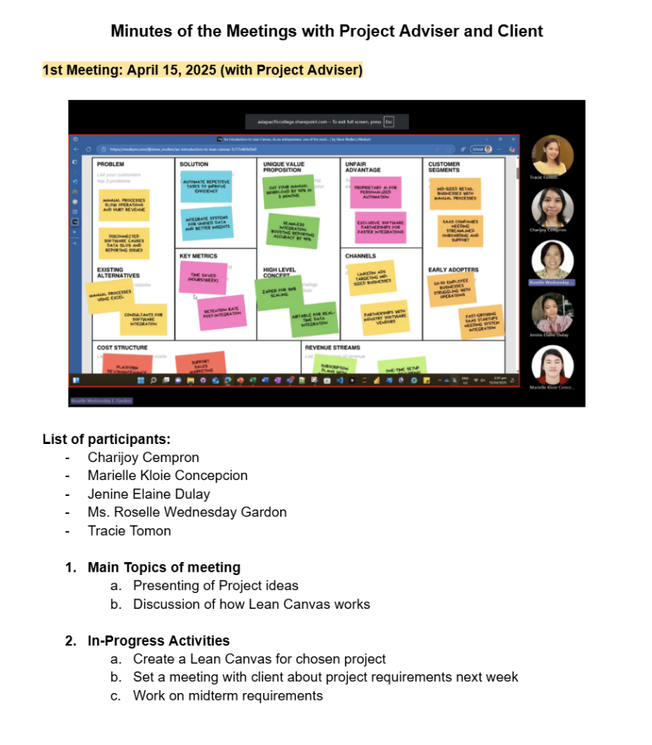

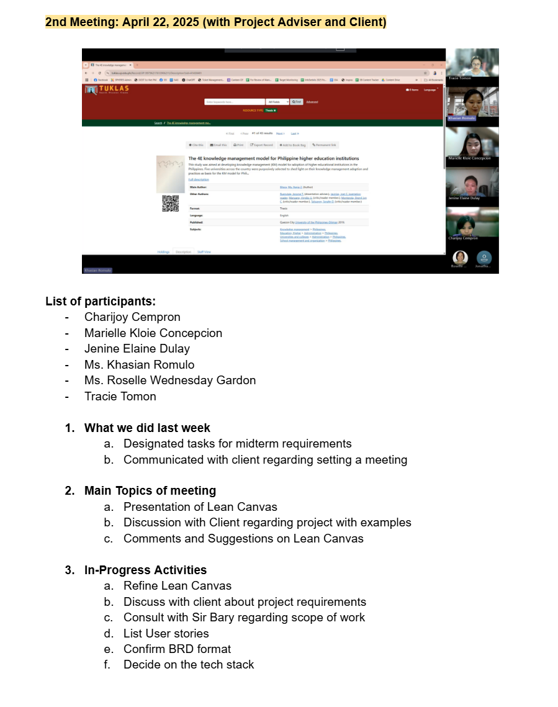

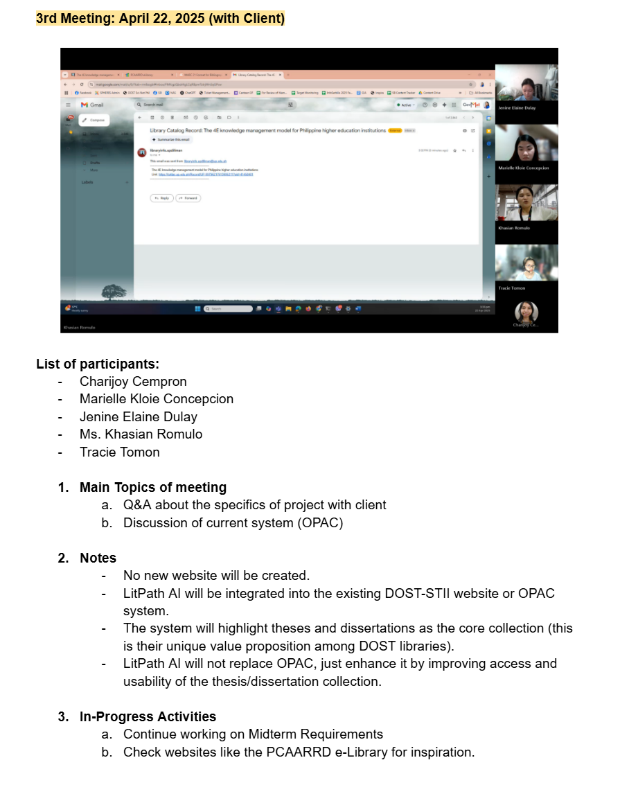

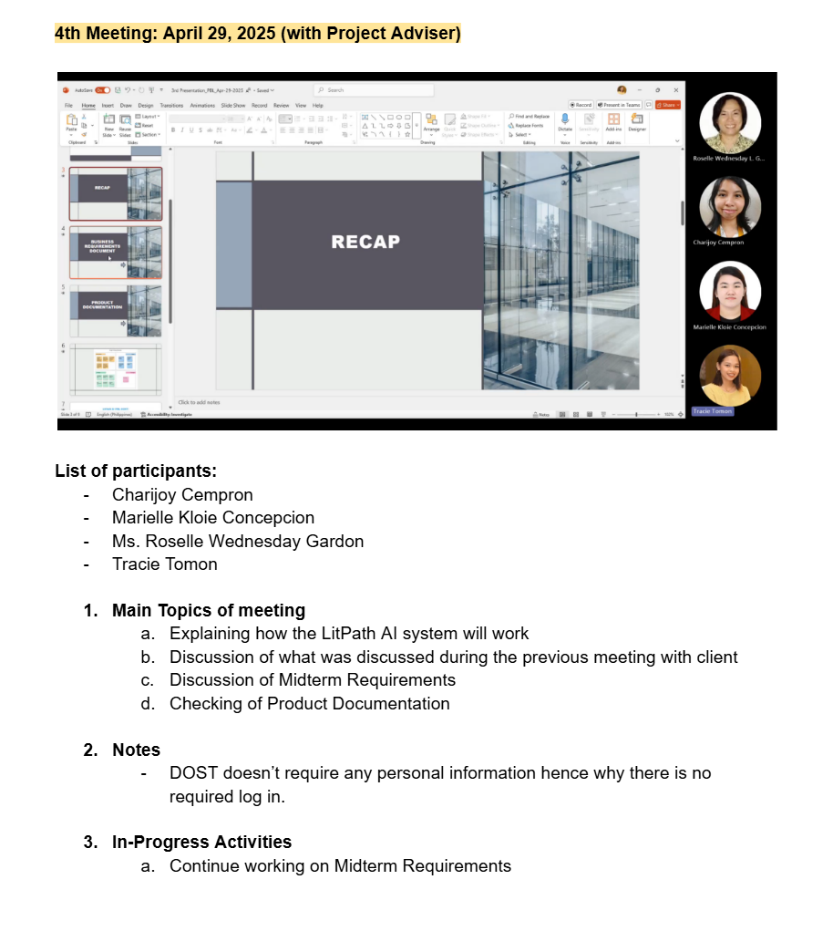



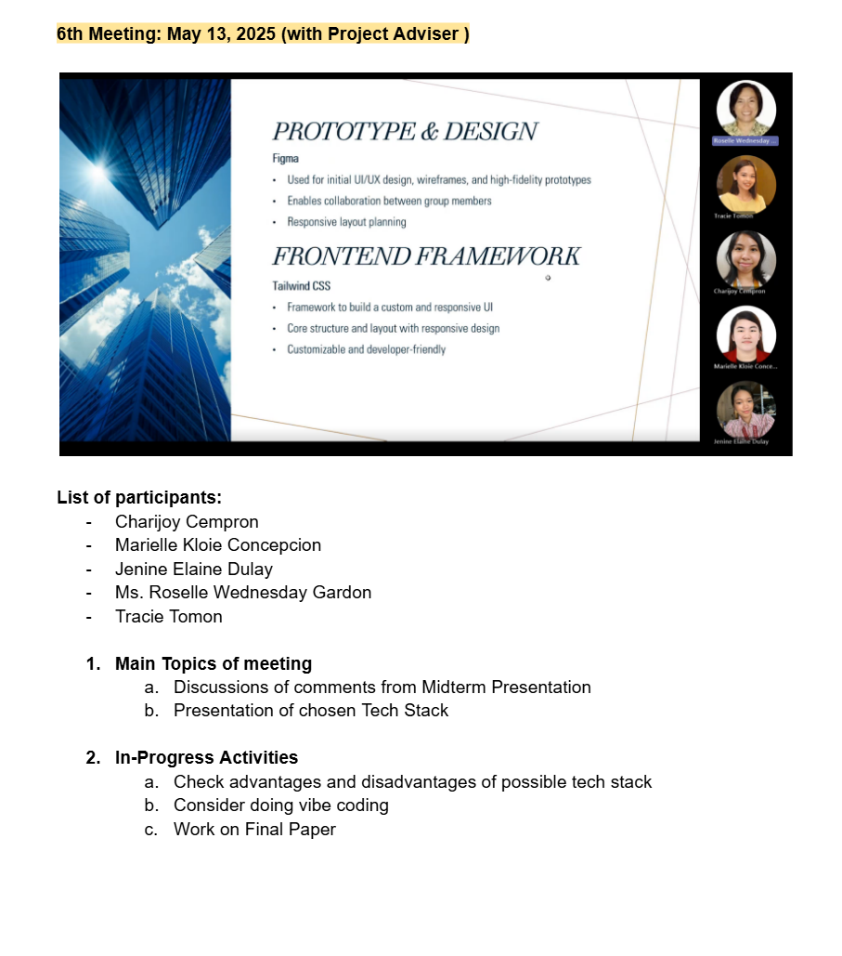

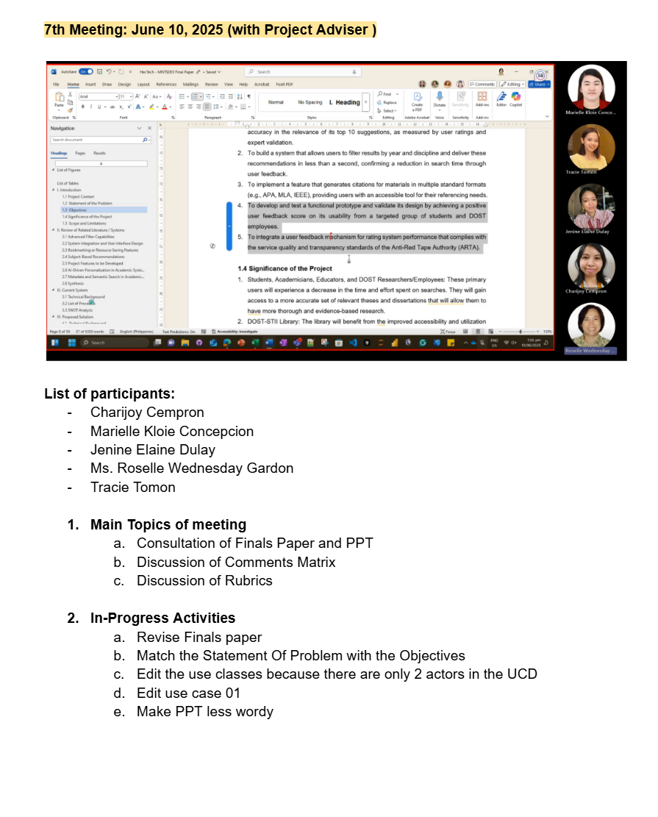

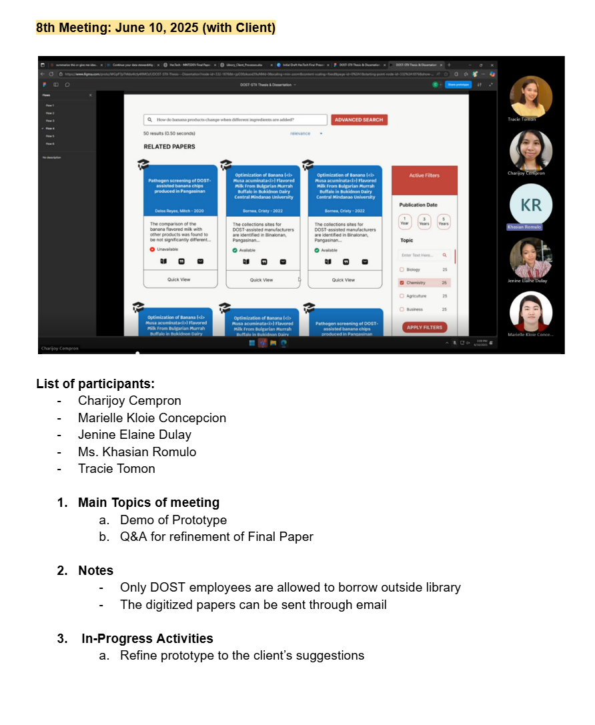

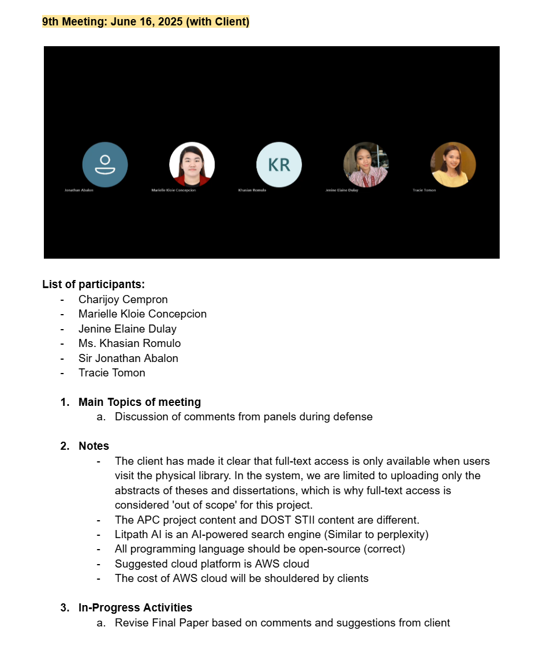

## Appendix C: Methodology

Scrum is a lightweight, agile framework designed for teams to collaborate on products through iterative and incremental delivery cycles. Built on empiricism and lean thinking, Scrum enables cross-functional, self-managing teams to deliver high-value products in short time periods called sprints, which typically last 1-2 weeks. The framework consists of three core components. First are roles or accountabilities of product owner, scrum master, and developers. Second are artifacts such as product backlog, sprint backlog, and increment. Third are events such as sprint planning, daily scrum, sprint review, and sprint retrospective. It emphasizes transparency, inspection, and adaptation through regular feedback loops, allowing teams to respond quickly to changing requirements, minimize risk, and continuously improve their processes while delivering working product increments frequently to stakeholders.

## Appendix D: Project Sharepoint Link

[HecTech - Home](https://asiapacificcollege.sharepoint.com/sites/HecTech2/SitePages/ProjectHome.aspx)

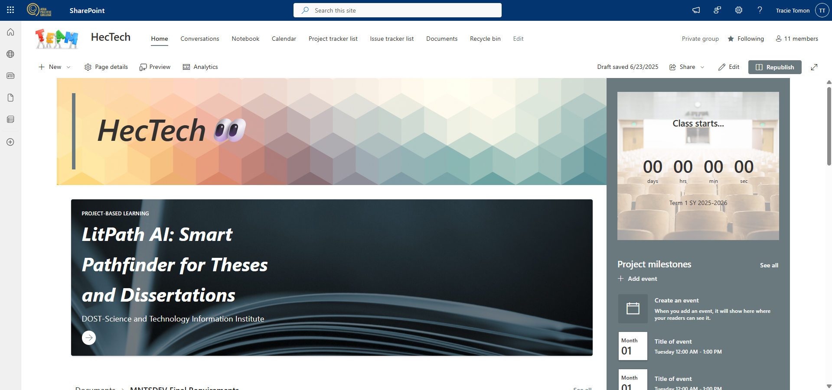

## Appendix E: Requirements Traceability Matrix

Table 6. Test Case Table

|  |  |  |  |
| --- | --- | --- | --- |
| **TC ID** | **UC ID** | **Test Case Name** | **Test Case Description** |
| TC-01 | UC-01 | Verify Theses and Dissertations Searched | User should be able to search for theses and dissertations |
| TC-02 | UC-02 | Verify Article Details Viewed | User should be able to view the full catalog and overview of academic works |
| TC-03 | UC-03 | Verify Prompted Questions Asked | User should be able to ask questions in the search bar and be assisted in finding relevant thesis/dissertation |
| TC-04 | UC-04 | Verify Thesis/Dissertation Bookmarked | User should be able to bookmark thesis/dissertation links by email |
| TC-05 | UC-05 | Verify Thesis/Dissertation Cited | User should be able to generate and copy citations in various formats |
| TC-06 | UC-06 | Verify Feedback Submitted | User should be able to submit feedback on his/her experience |
| TC-07 | UC-07 | Verify Related Papers Viewed | User should be able to view the list of related papers of the chosen thesis |
| TC-08 | UC-08 | Verify Admin Login | Librarian should be able to login successfully |
| TC-09 | UC-09 | Verify Usage Analytics Viewed | Librarian should be able to access usage data and metrics |
| TC-10 | UC-10 | Verify Exposed Data | System should be able to read from OPAC database |
| TC-11 | UC-11 | Verify Query Analyzed | AI should be able to analyze user intent from query |
| TC-12 | UC-12 | Verify Ranked Relevance | AI should be able to rank the theses or dissertations by relevance |

Table 18. RTM (Requirement Traceability Matrix)

|  |  |  |
| --- | --- | --- |
| **Business Rqt No** | **Use Case ID** | **Test Case ID** |
| BR-01 | UC-01 | TC-01 |
| BR-02 | UC-02 | TC-02 |
| BR-03 | UC-03 | TC-03 |
| BR-04 | UC-04 | TC-04 |
| BR-05 | UC-05 | TC-05 |
| BR-06 | UC-06 | TC-06 |
| BR-07 | UC-07 | TC-07 |
| BR-08 | UC-08 | TC-08 |
| BR-09 | UC-09 | TC-09 |
| BR-10 | UC-10 | TC-10 |
| BR-11 | UC-11 | TC-11 |
| BR-12 | UC-12 | TC-12 |

## Appendix F: RACI Matrix

Table 19. RACI Matrix Table

|  |  |  |  |  |
| --- | --- | --- | --- | --- |
| **Activity/ Deliverable** | **Project Team (Developers)** | **Project Adviser** | **Library Staff (DOST-STII)** | **End Users (Students/Researchers)** |
| Define scope, stakeholders, and requirement | R | A | C | I |
| Create wireframes and design mockups | R | C | I | I |
| Refine UI based on feedback | R | I | C | I |
| Develop separate LitPath AI database | R | C | I | I |
| Use APIs to integrate AI search engine model | R | C | I | I |
| Develop citation generator (APA, MLA, etc.) | R | C | I | I |
| Develop the feedback and bookmarking feature | R | C | C | I |
| Create user interface and dashboard | R | C | I | I |
| Ensure mobile/responsive design compatibility | R | C | I | I |
| Conduct system testing (functionality, compatibility) | R | C | I | I |
| Collect and analyze user feedback | R | I | C | I |
| Deploy LitPath AI to production | R | C | C | I |
| Provide post-release support and monitoring | R | I | I | I |
| Manage bug fixes, hotfixes, and updates | R | I | I | I |
| Implement feedback enhancements | R | I | C | I |